Task on the Jenkins -02

- Configure 2 slave machines in the Jenkins master.
Lets create instance
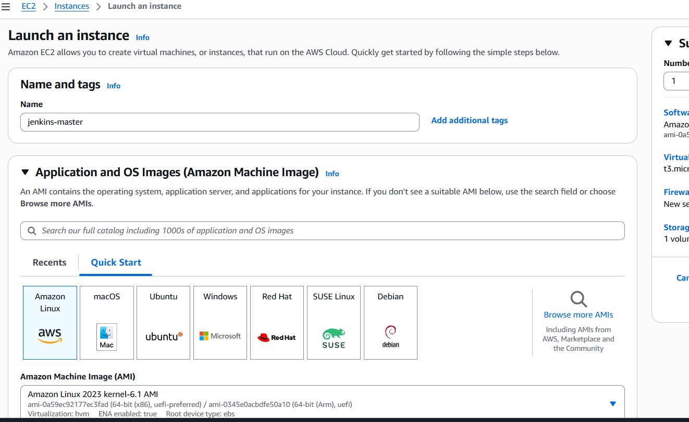
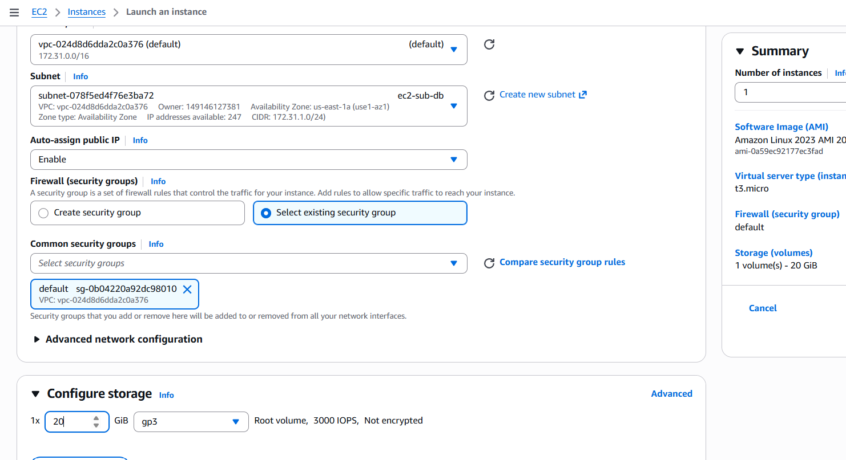
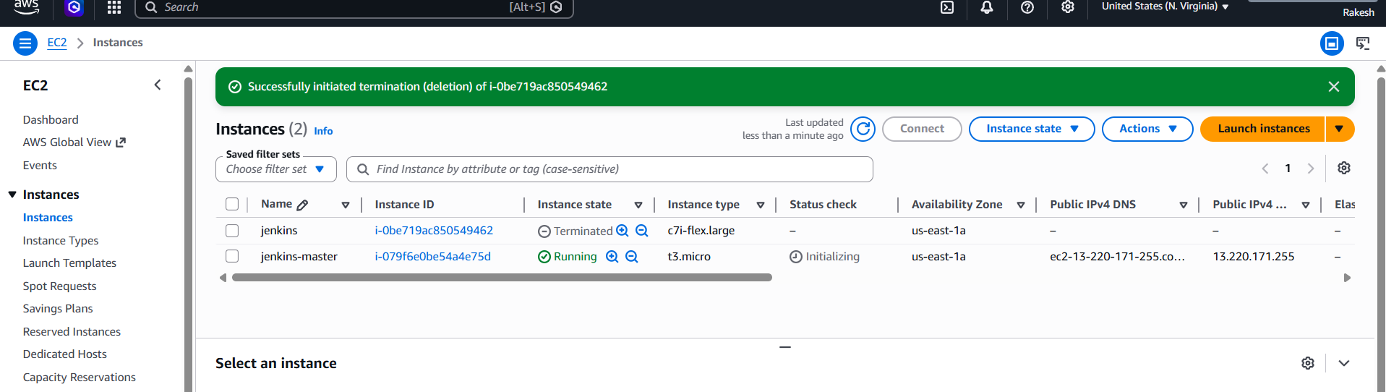
And create 2 instances for 2slaves
Here we have created three instances
- Jenkins Master
- Slave-1
- Slave-2
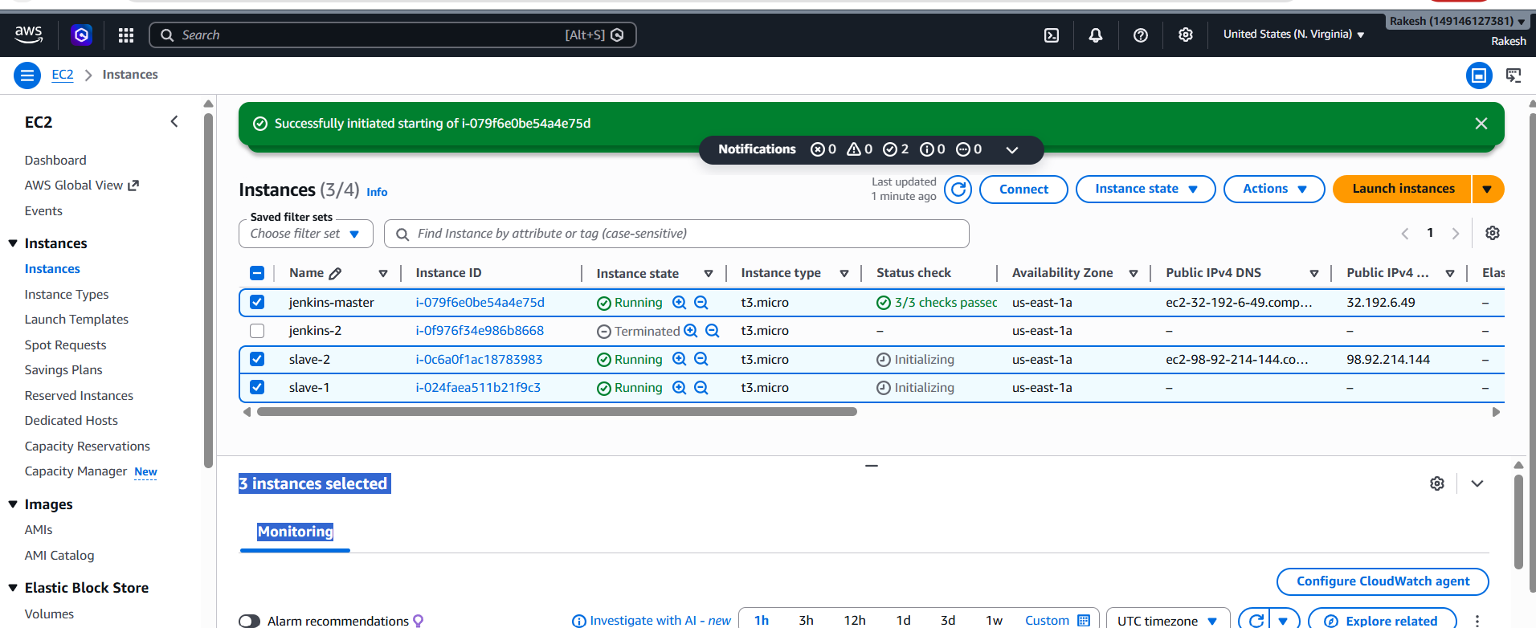
Connect to Jenkins master
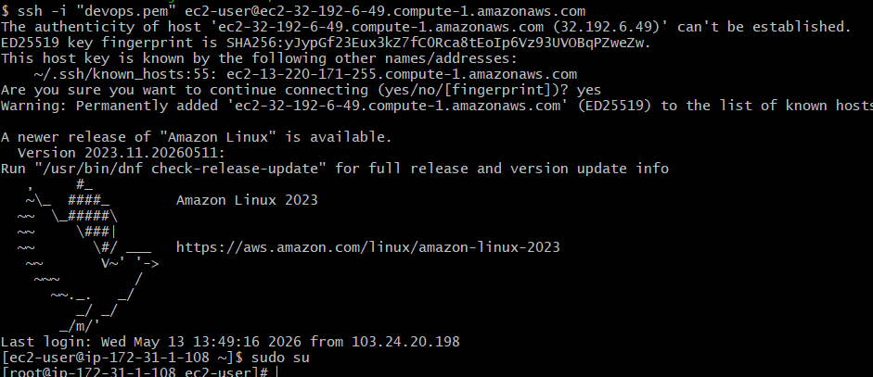

Install Jenkins
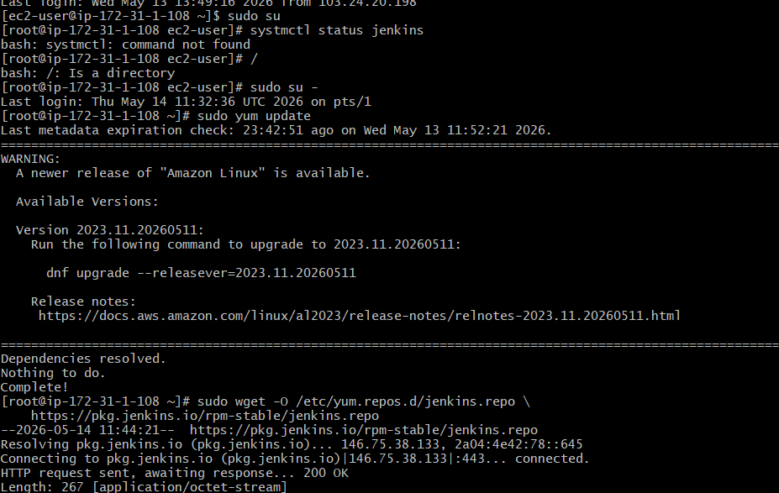
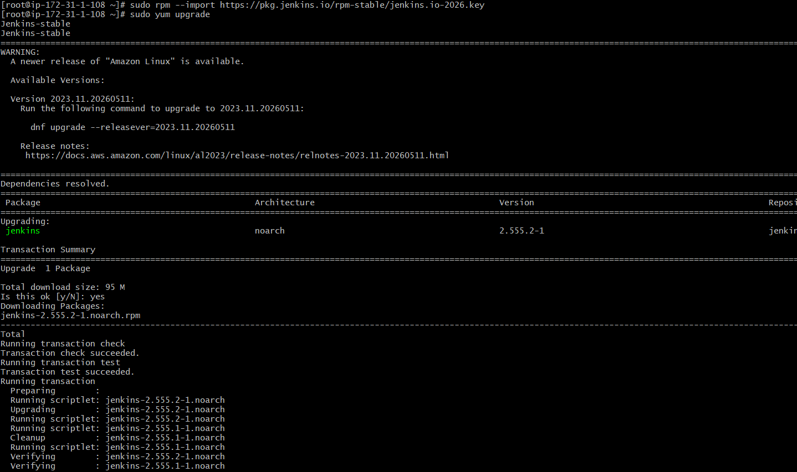
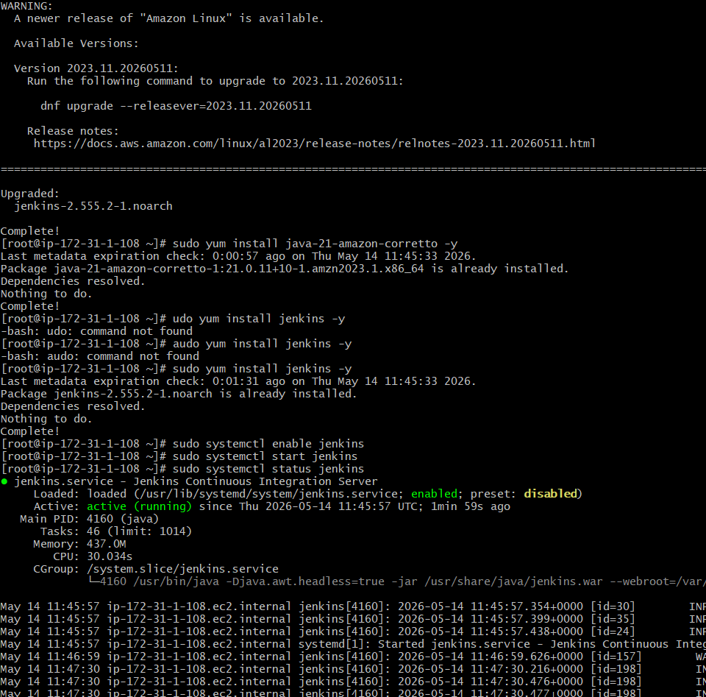

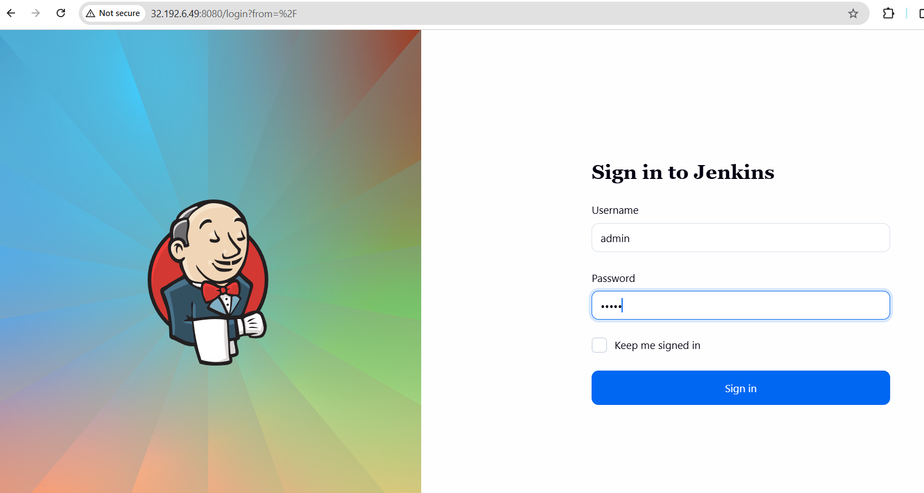
Login to both the slaves through ssh
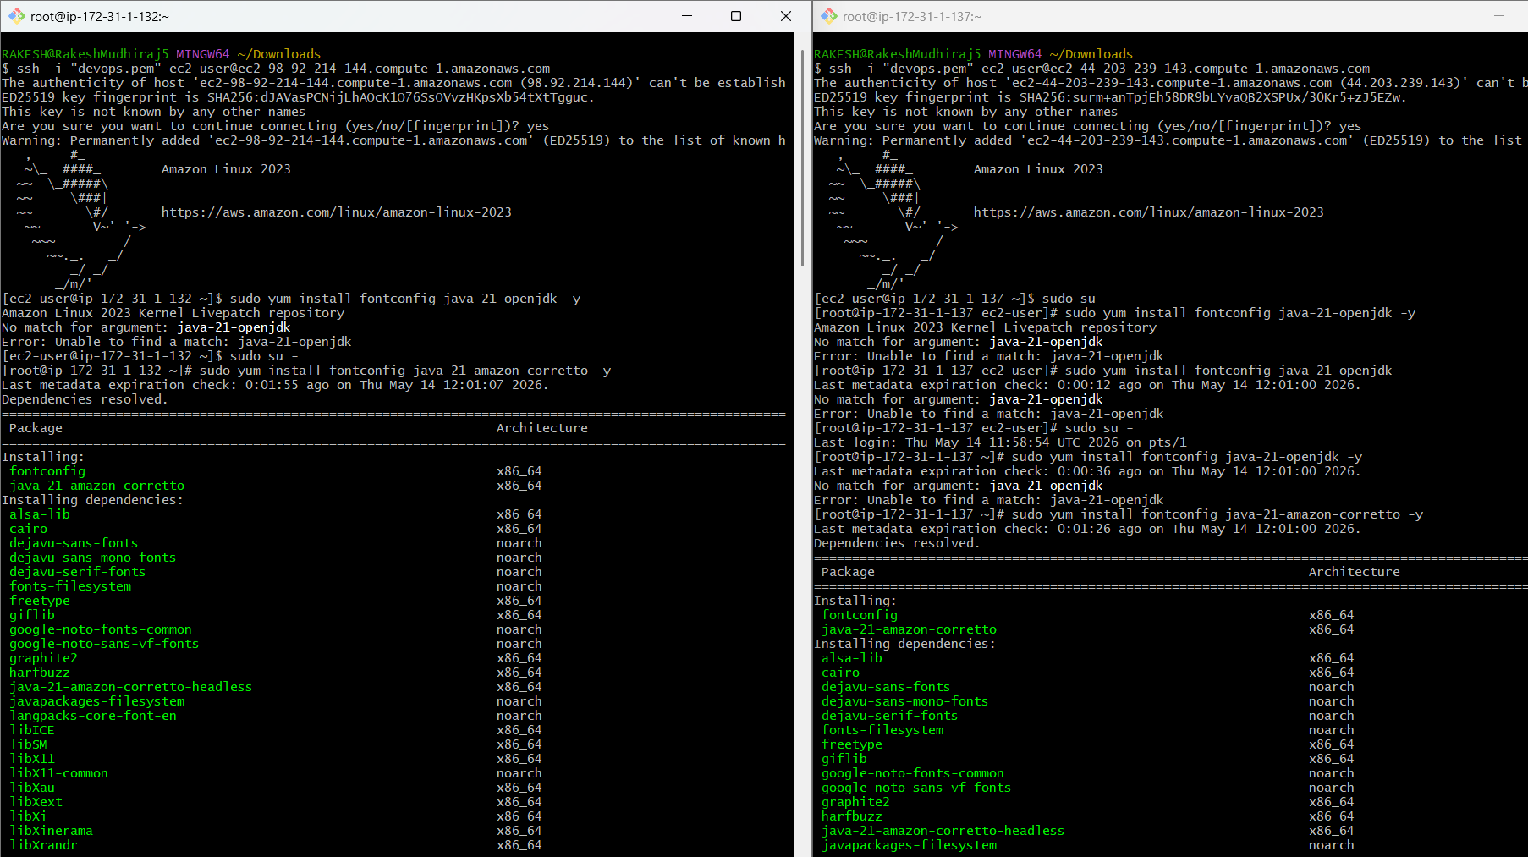
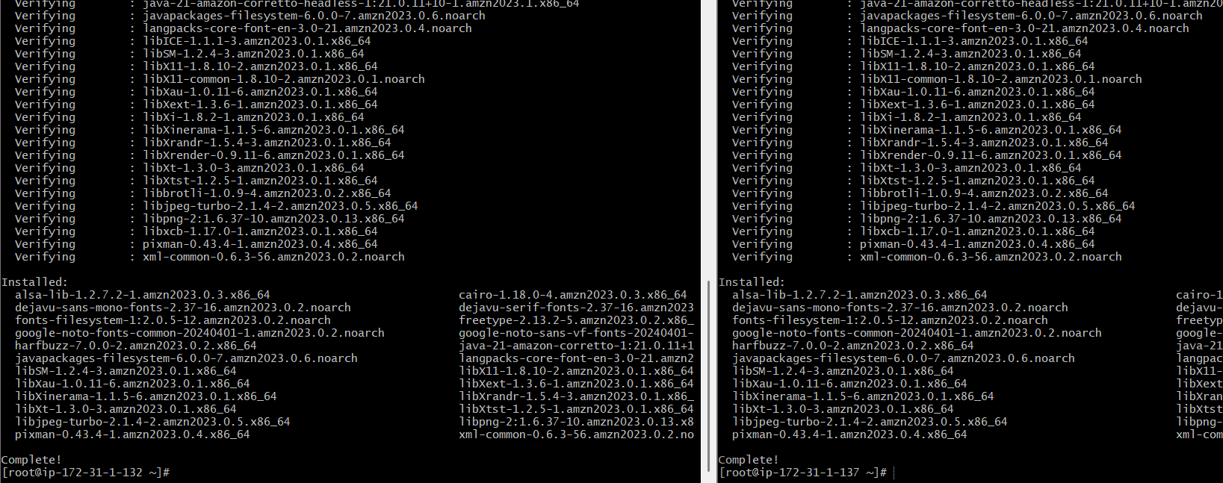

Install java in both slaves
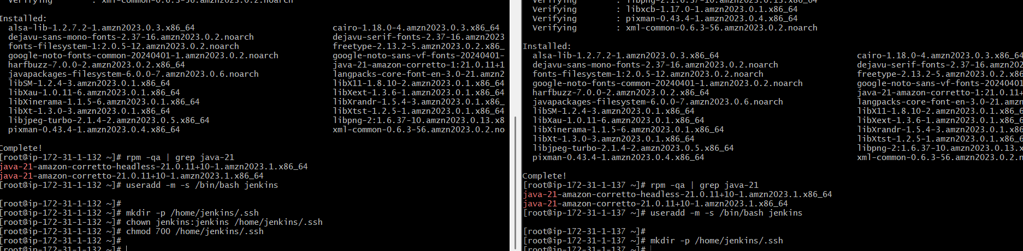
Create jenkins user
Create .ssh directory for jenkins use

Prepare the Jenkins Controller (Master) – we need to do in Jenkins-master server
Ensure the 'jenkins' user exists
# The Jenkins RPM package normally creates this user automatically.
# This command checks and creates it only if missing.
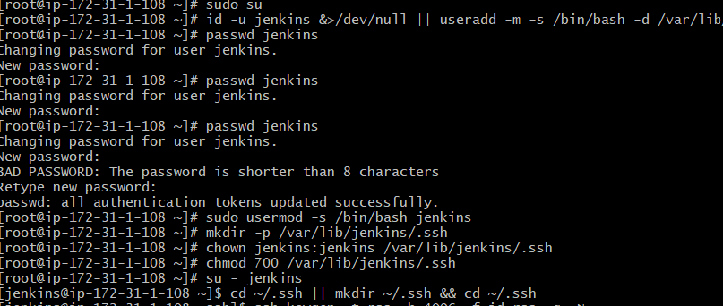
Now switch to Jenkins user -- Navigate to .ssh directory
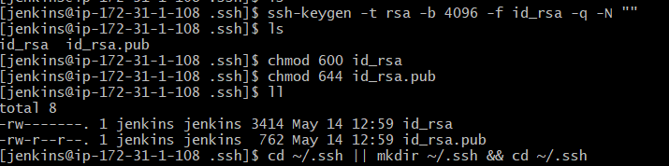
Generate RSA key pair
Set correct permission
Display the public key (you will need it for slaves) -- exit back to root
Public key: `/var/lib/jenkins/.ssh/id_rsa.pub`
Private key: /var/lib/jenkins/.ssh/id_rsa
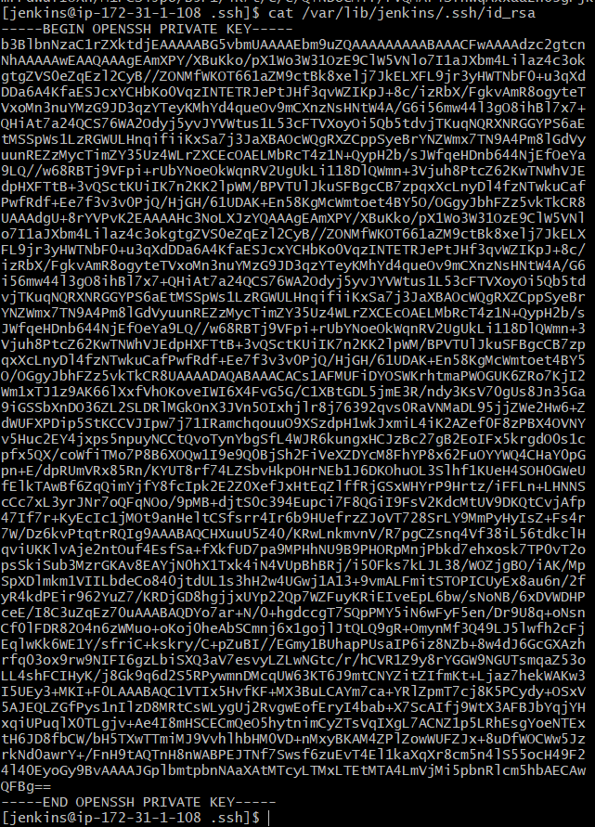

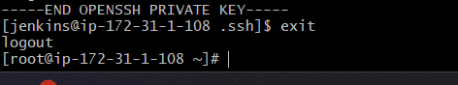
Copy the Public Key to Both Agents
In both slave01 & slave02
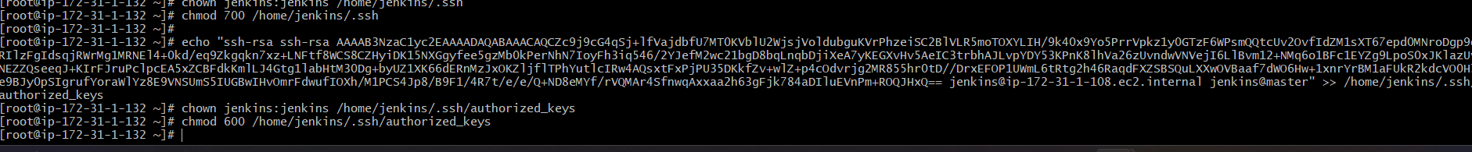
Add Agents' Host Keys to known_hosts
Go to Jenkins server
Slave-1 and slave -2
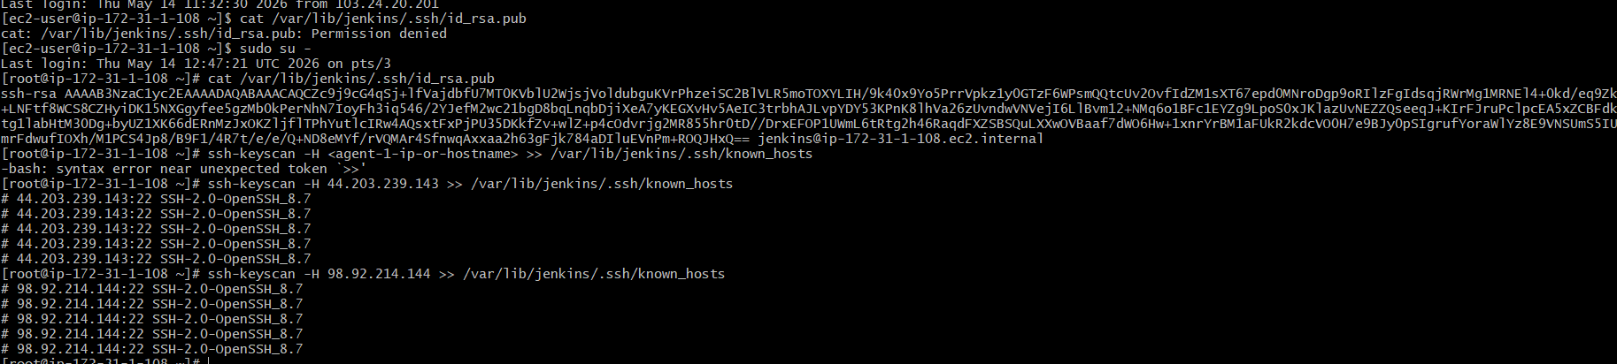
Fix ownership and permissions
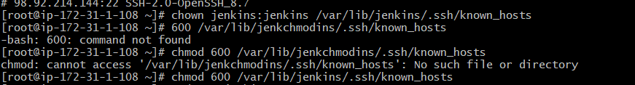
Test Password-less SSH Connectivity (From Master to Slave Machines)
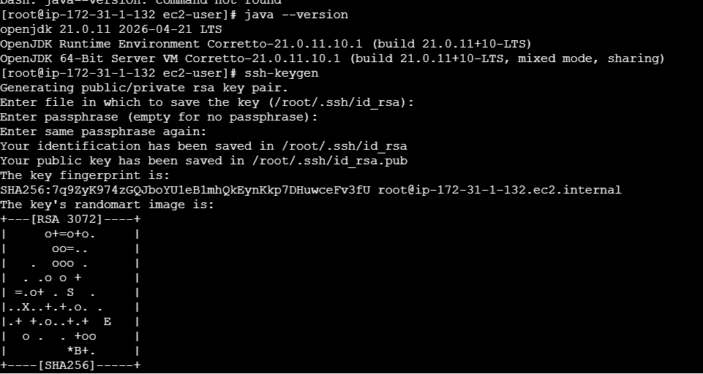

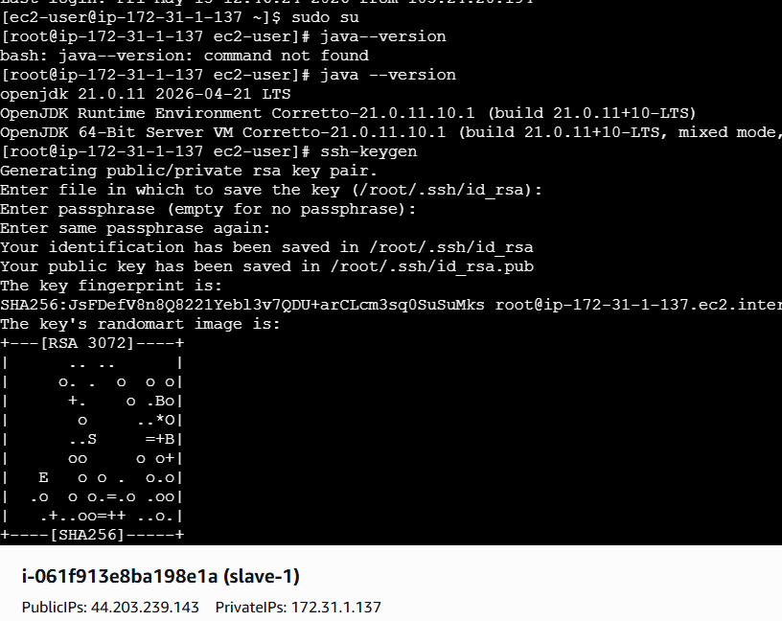

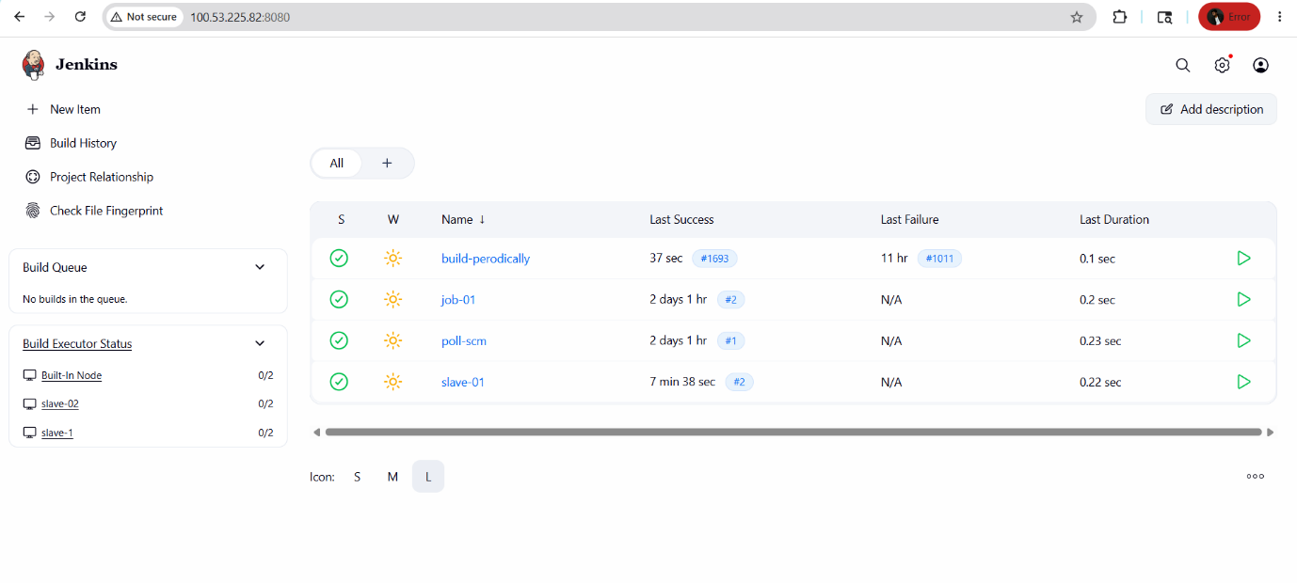
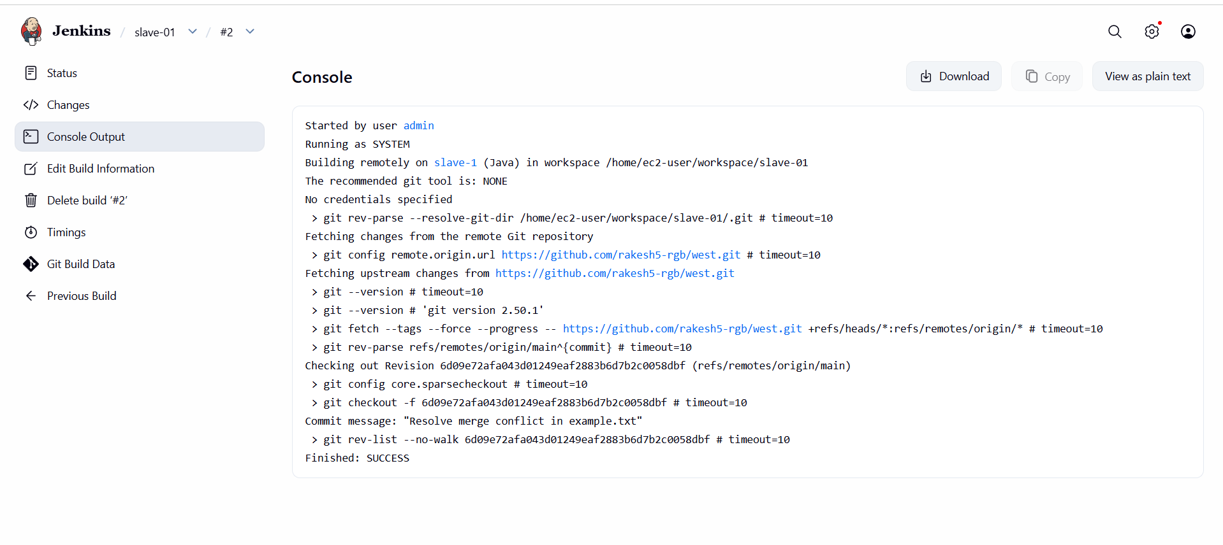
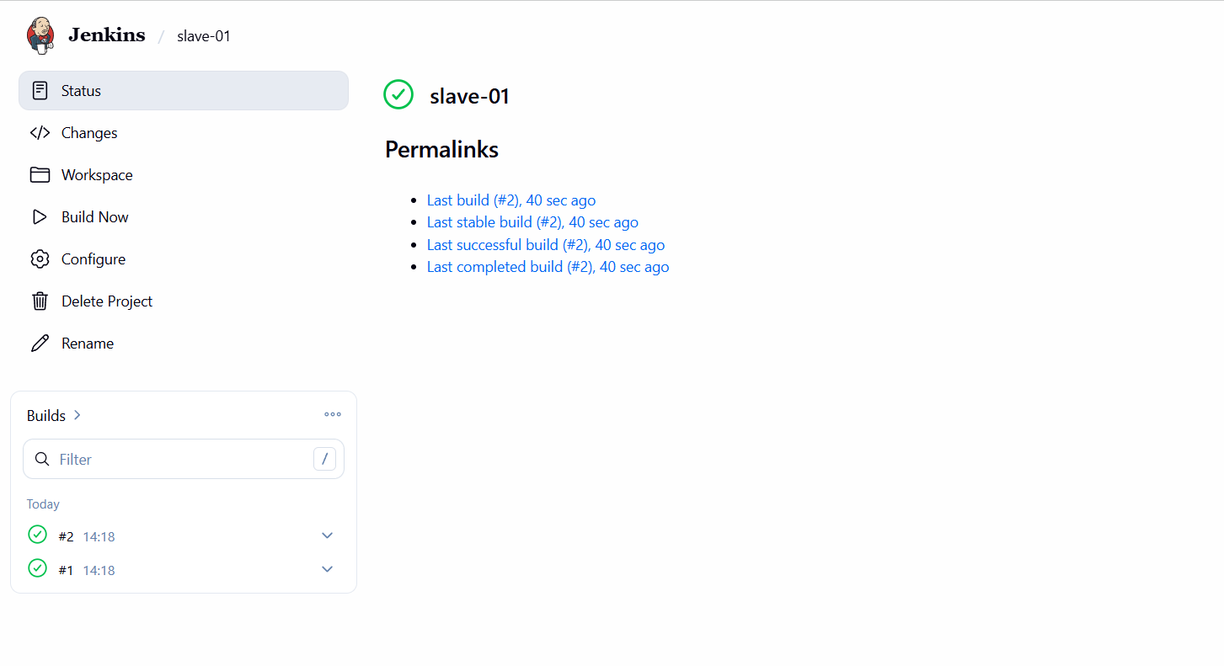

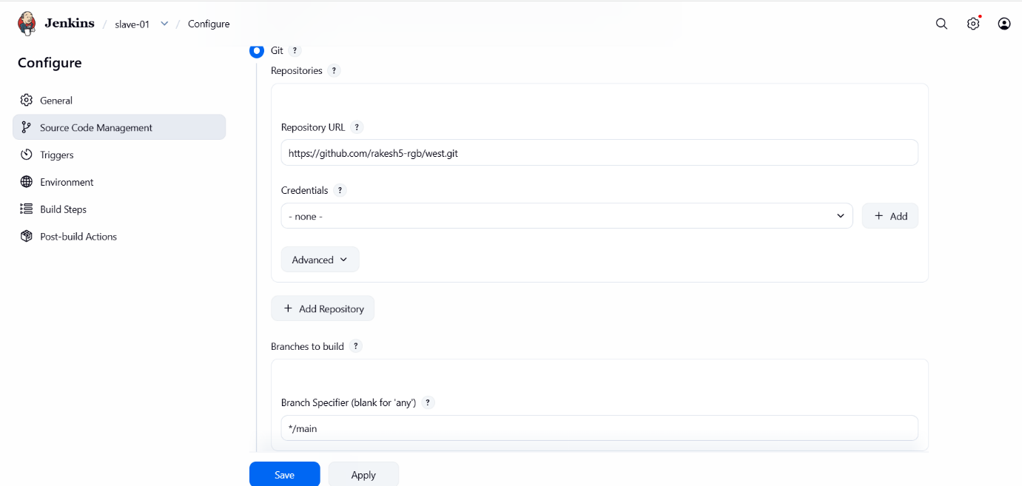
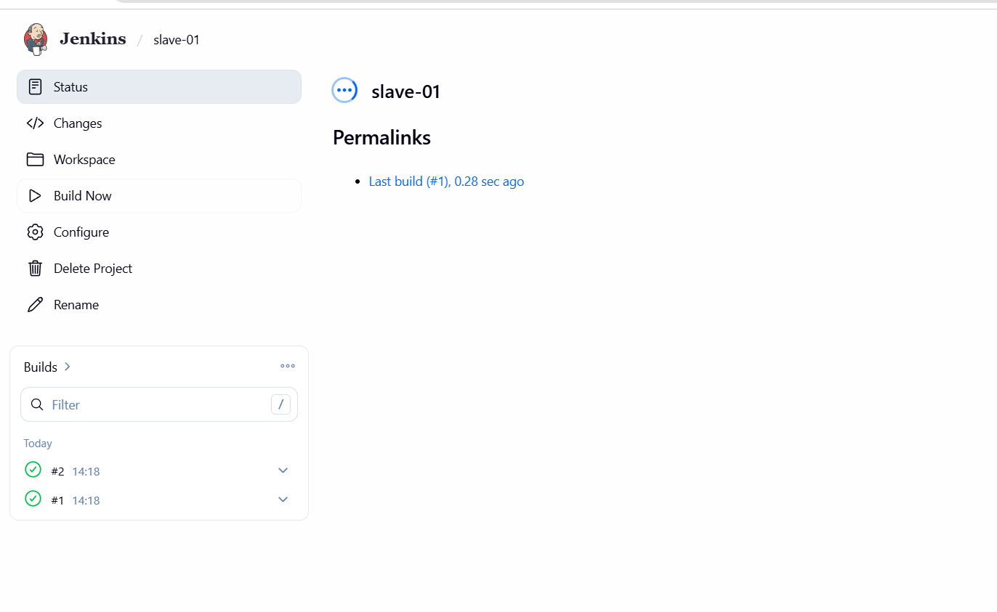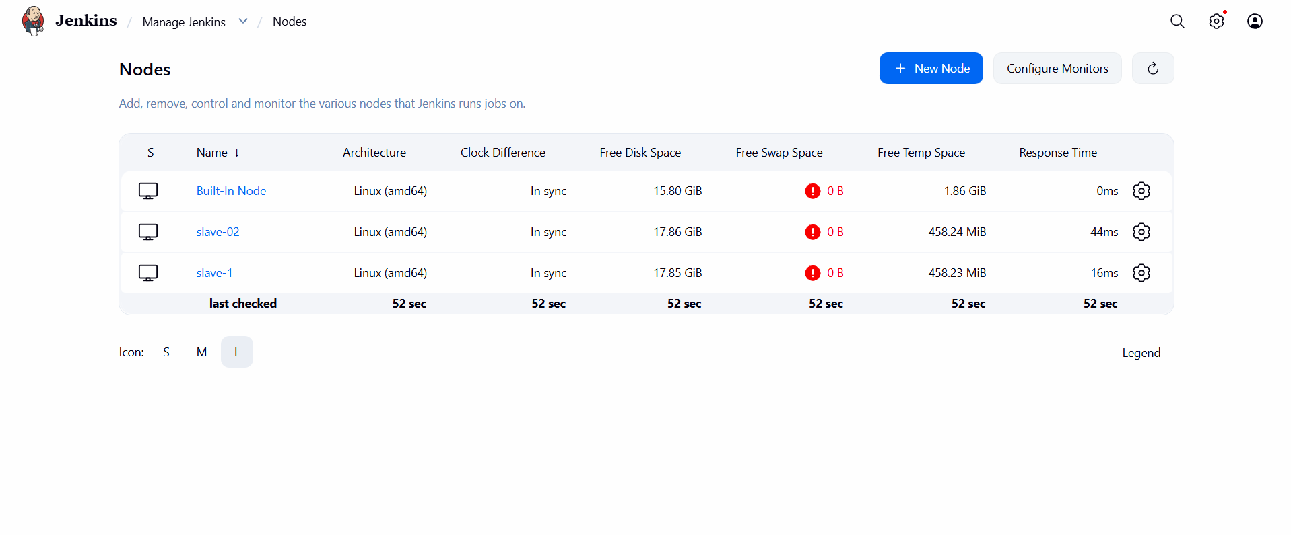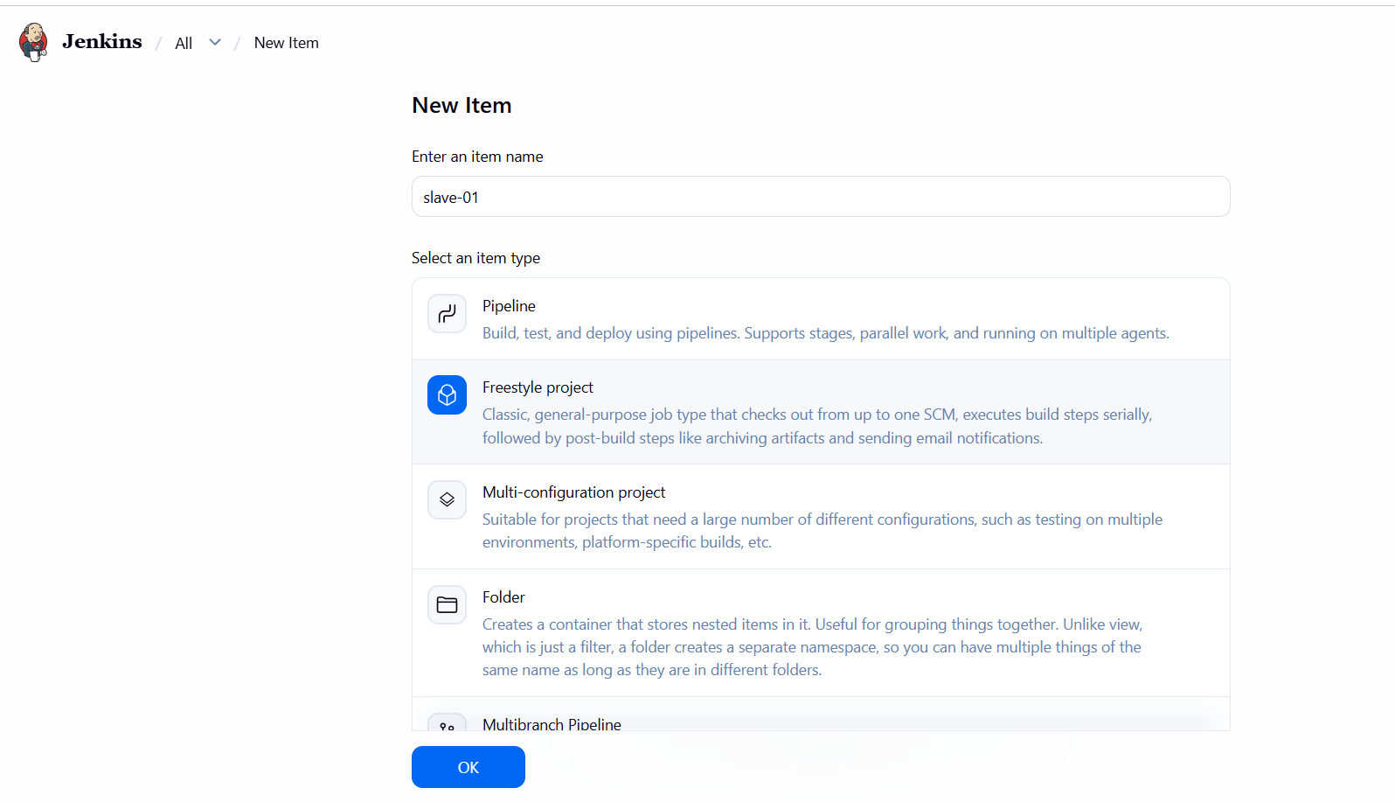

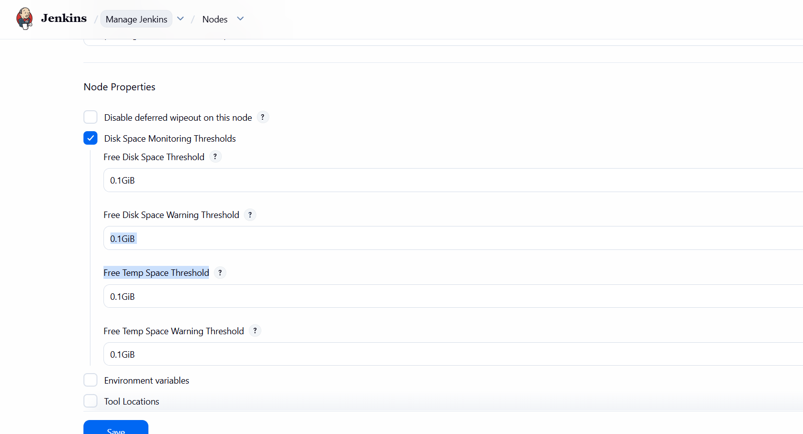

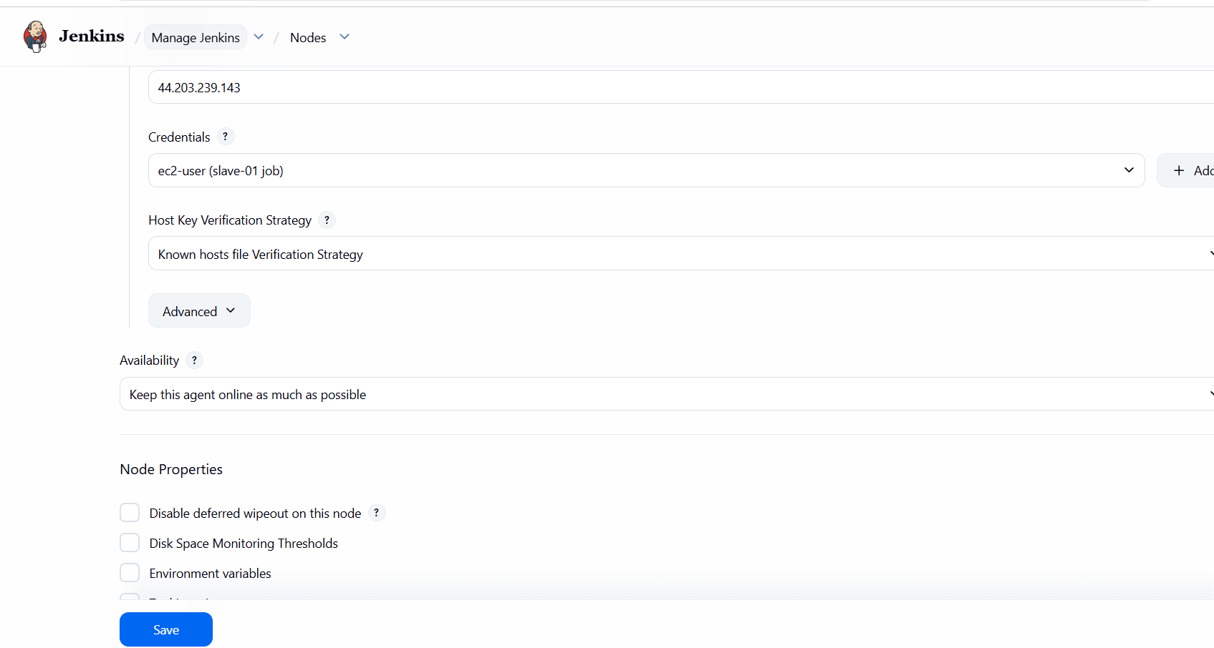

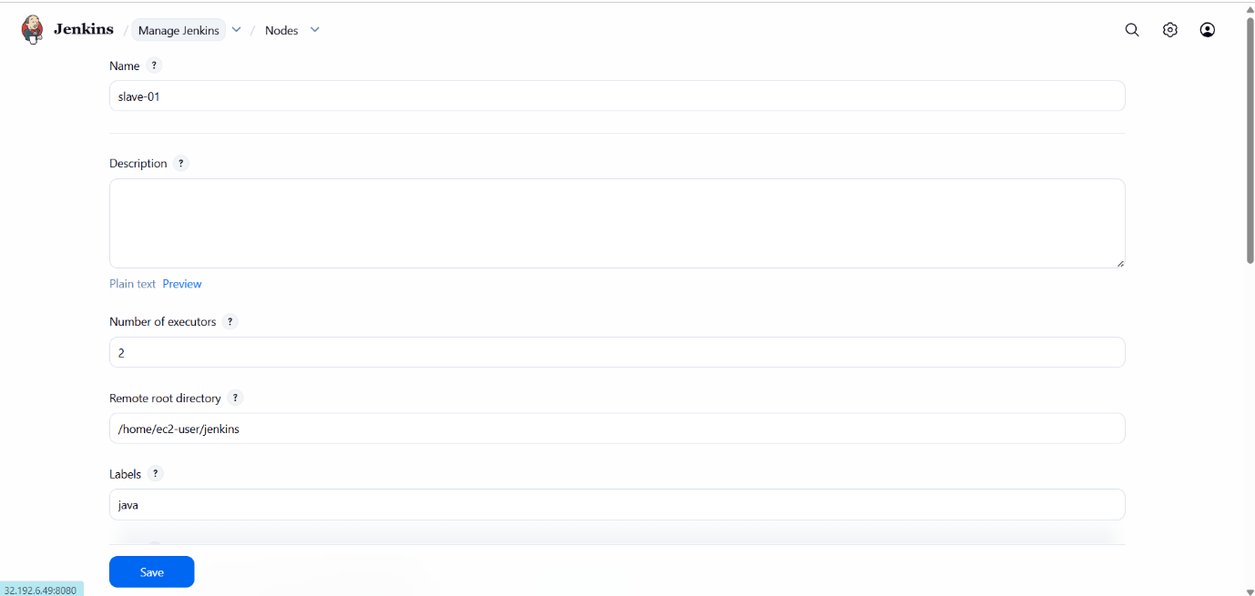
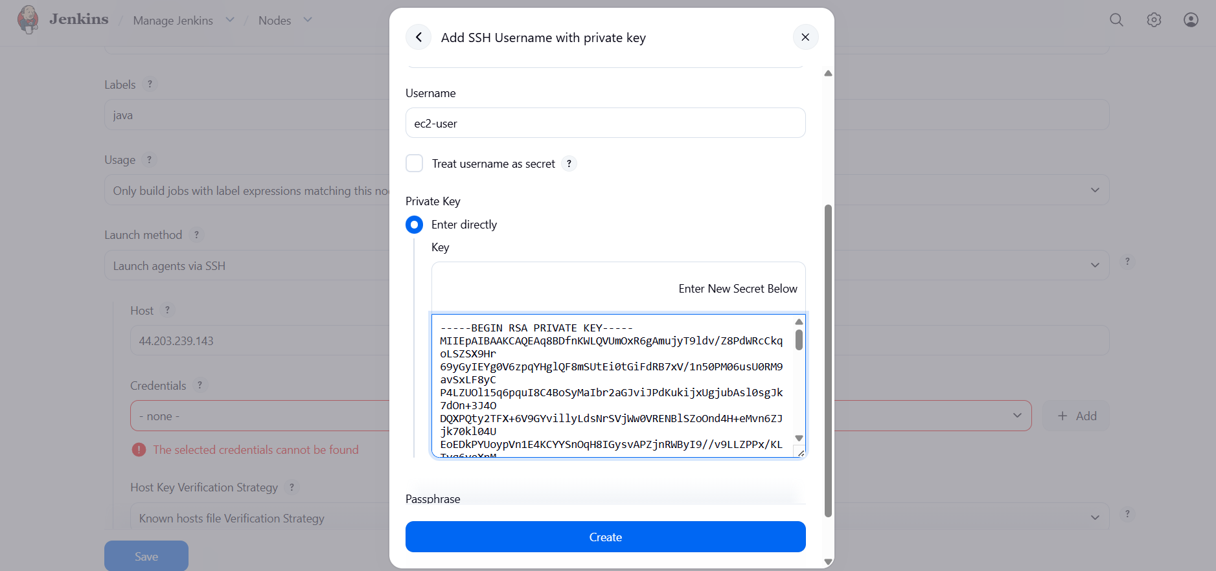



- Configure webhooks to the Jenkins job.
Go to manage Jenkins --- click on plugins
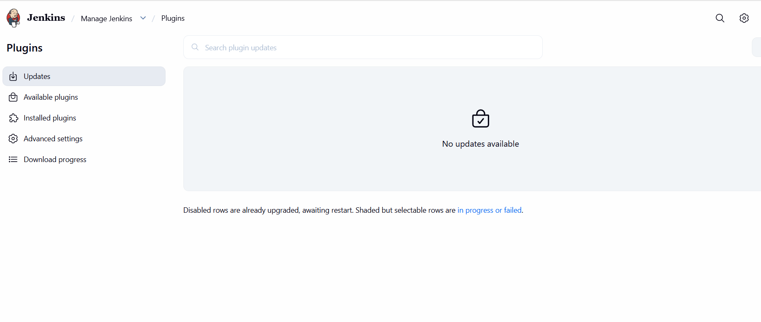
Check whether the git plugins are installed
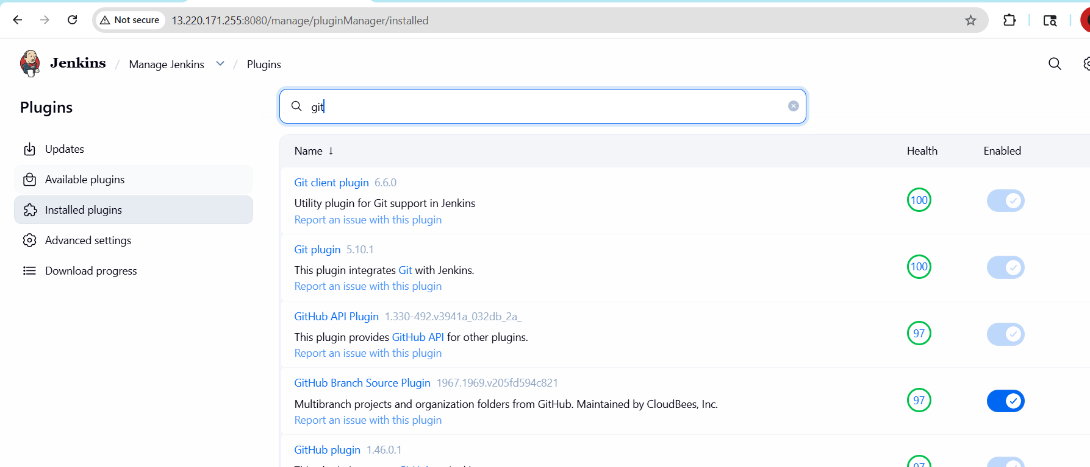
Create a new job
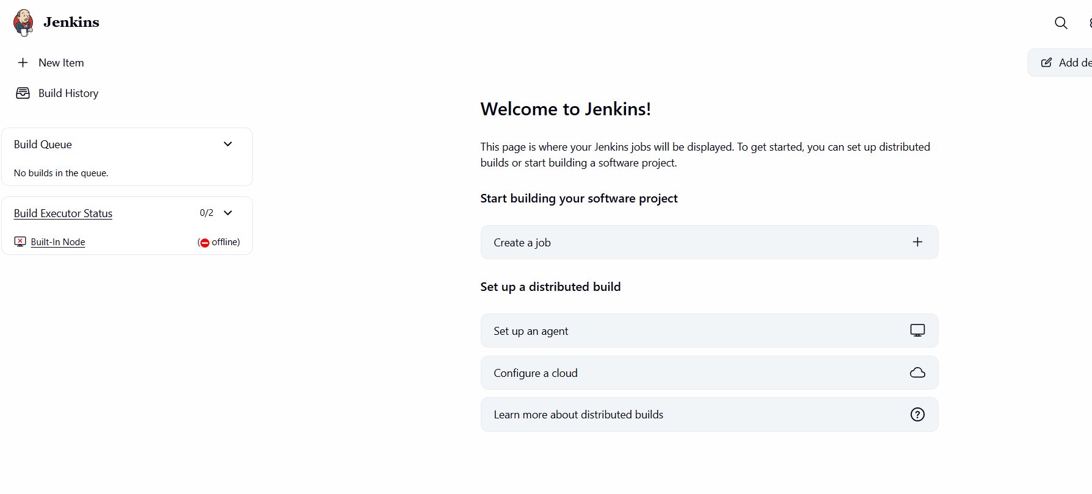
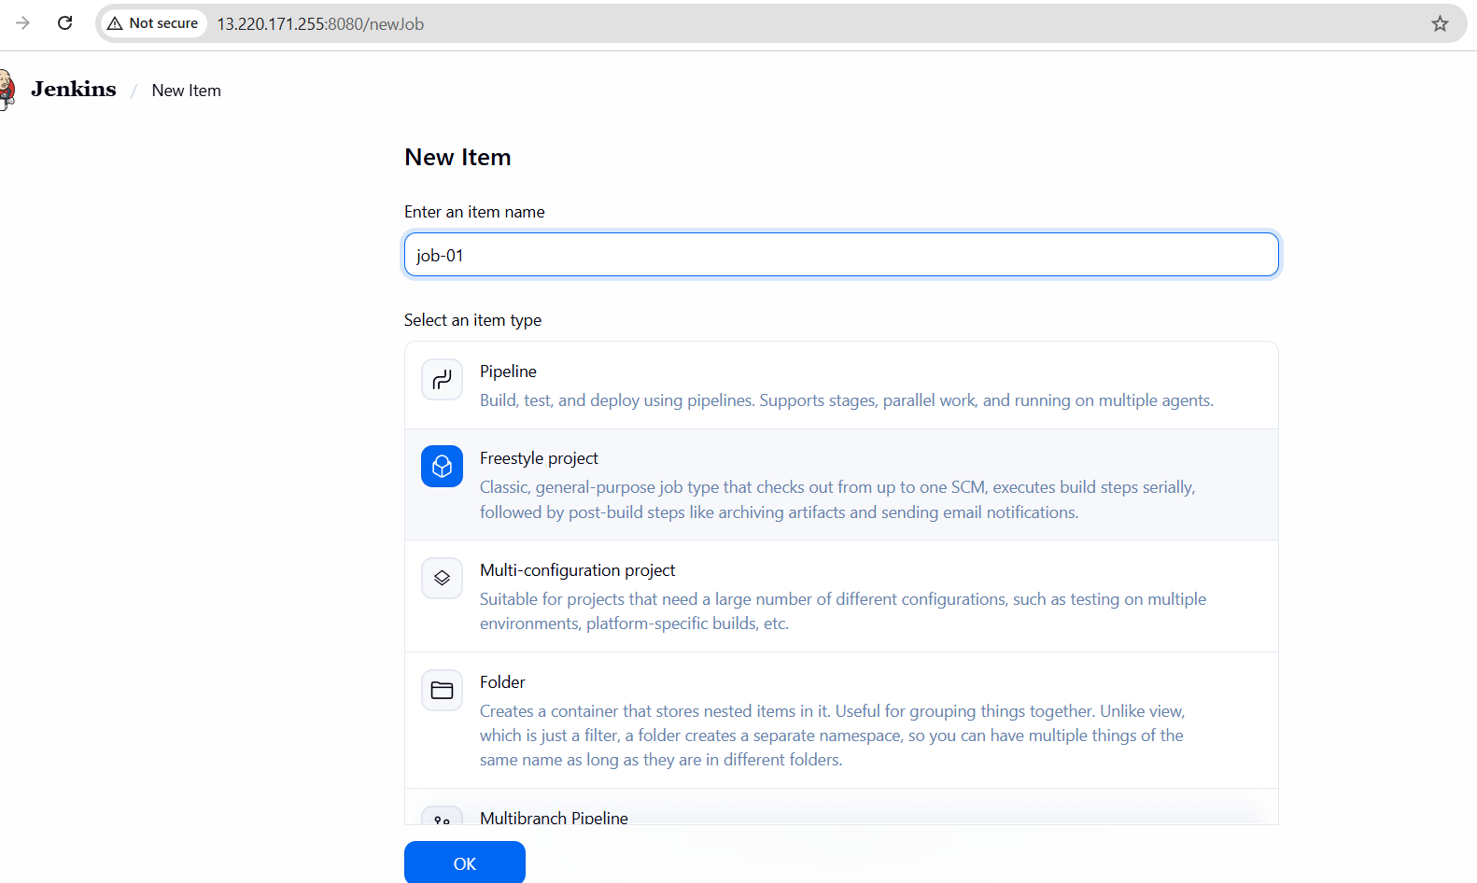
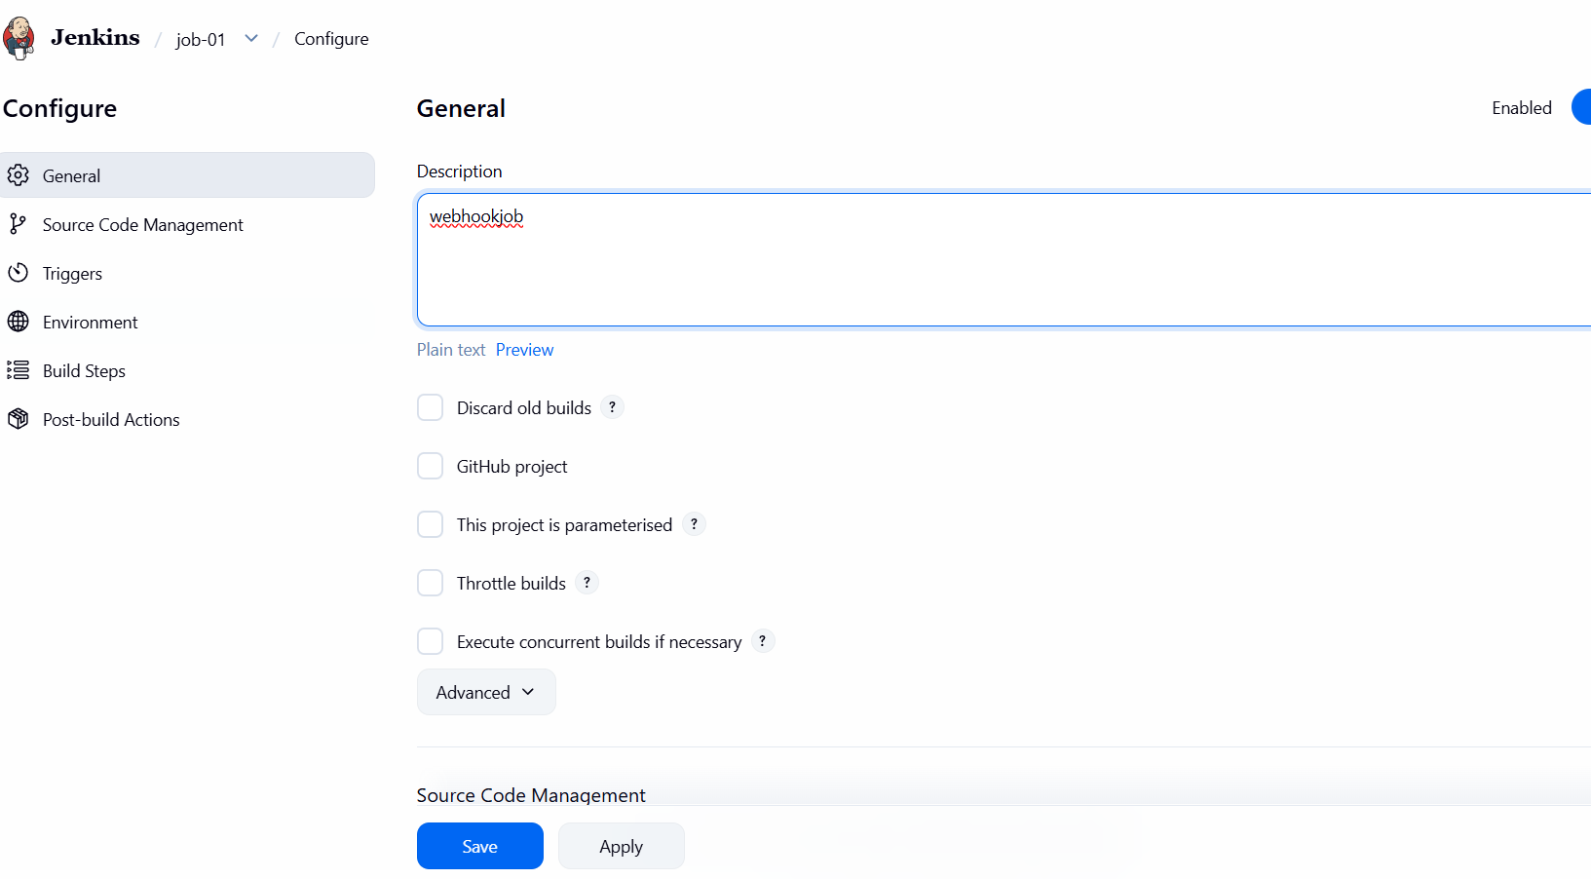
Under source code management -- click on git --provide repo url
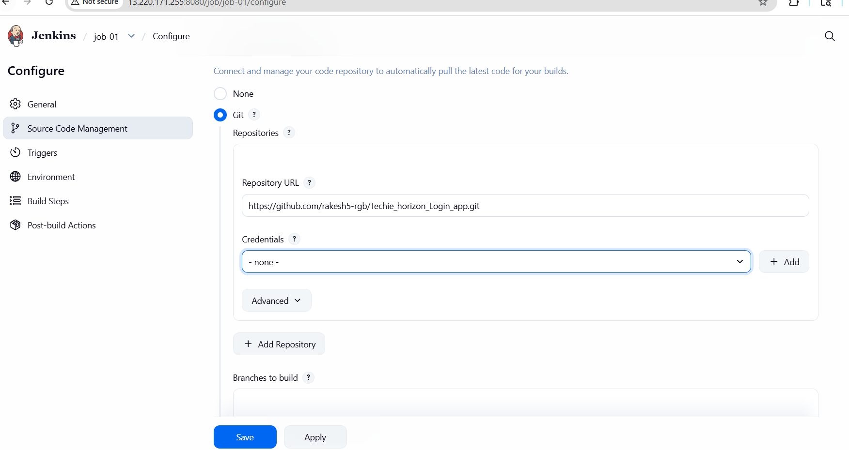
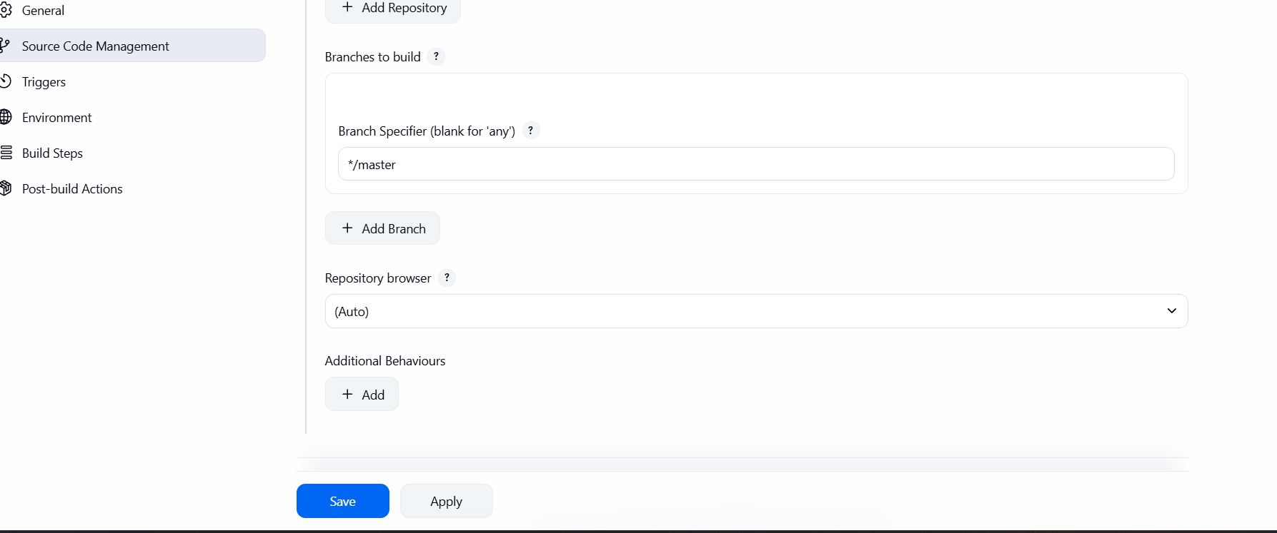
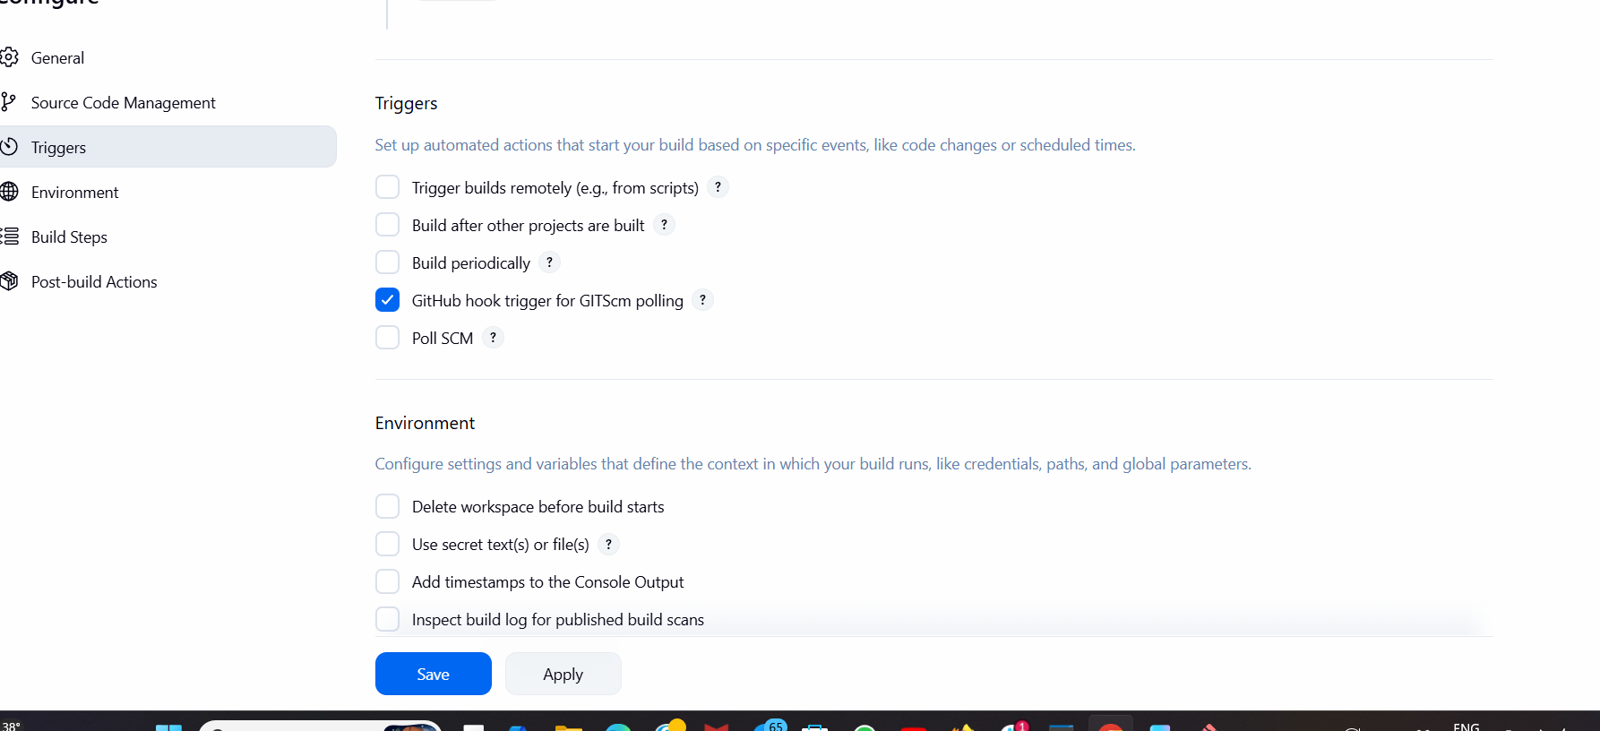
Choose build step as execute shell
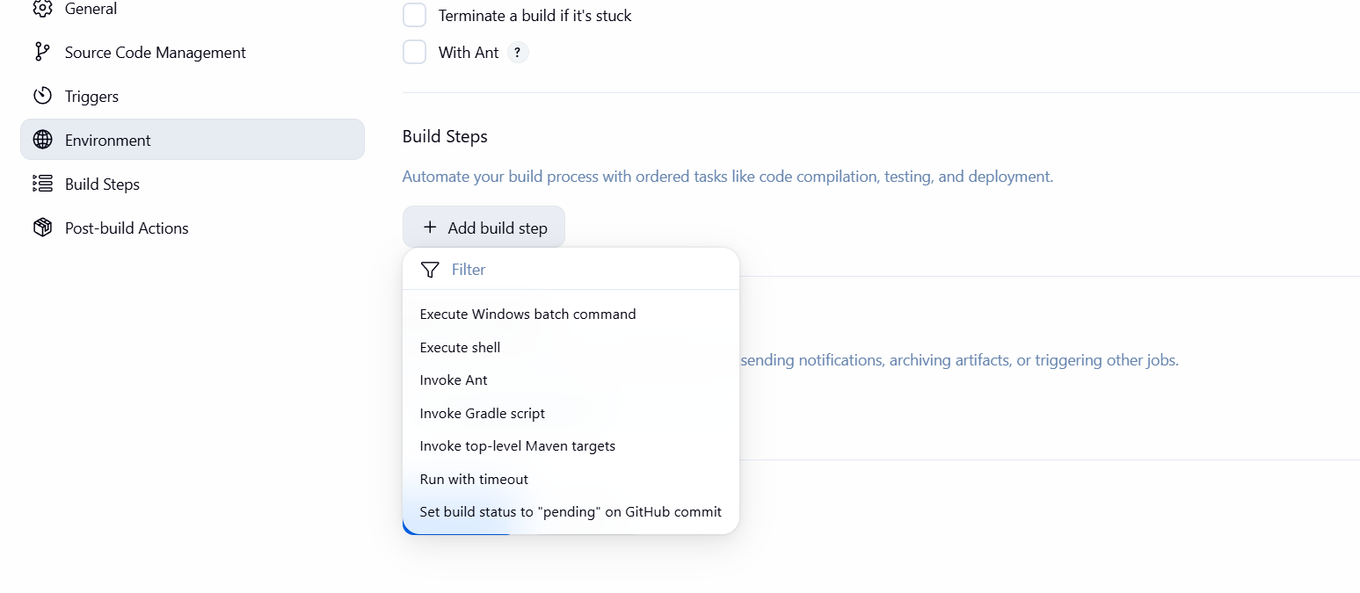
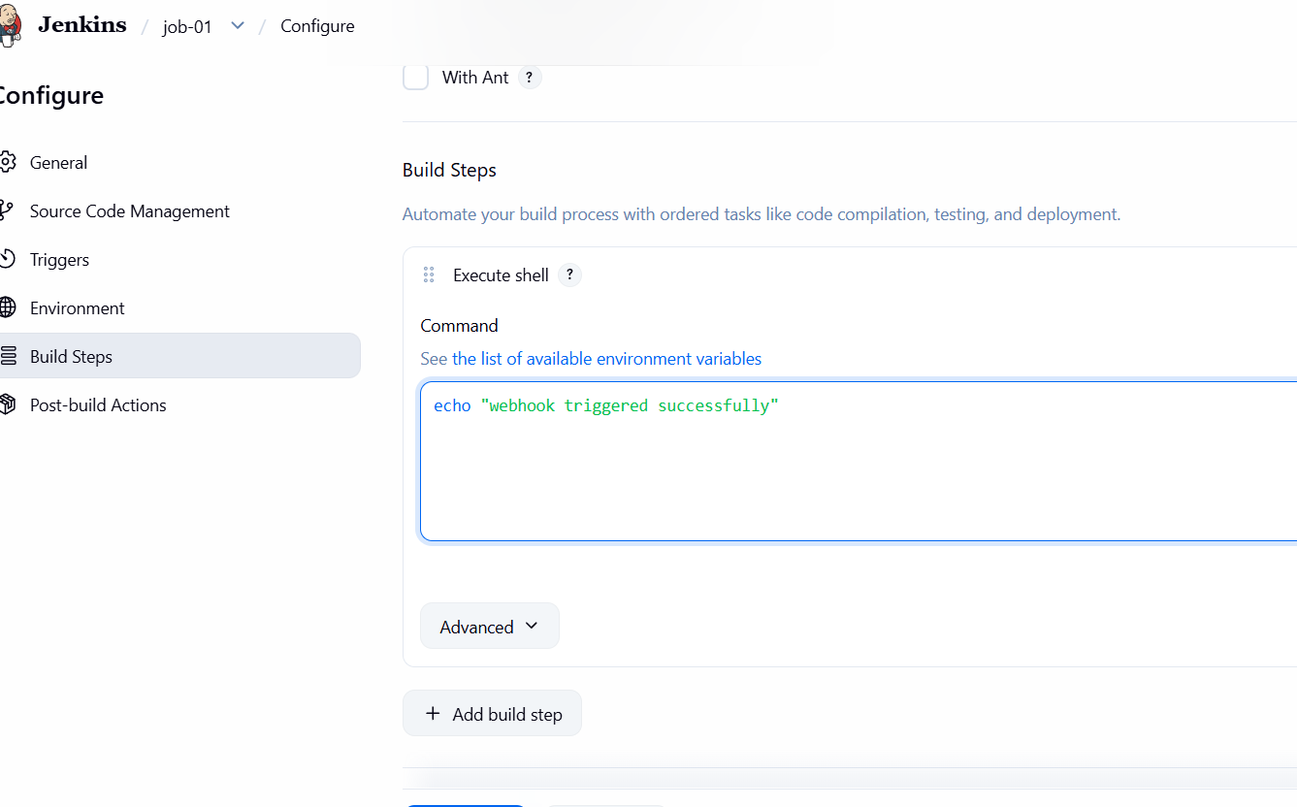
Go to github repository settings and create webhooks
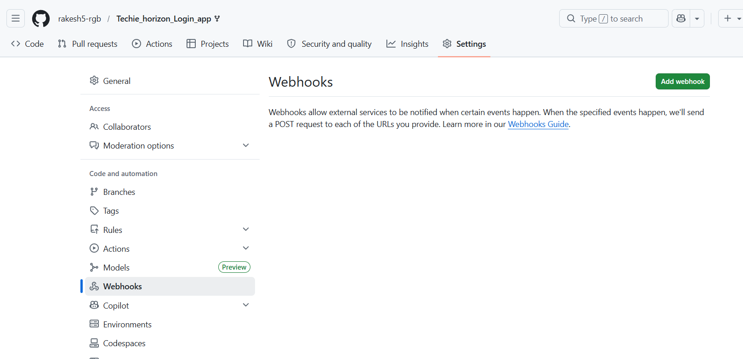

Add payroll url-- give public ip of Jenkins server, portnumber /github-webhook

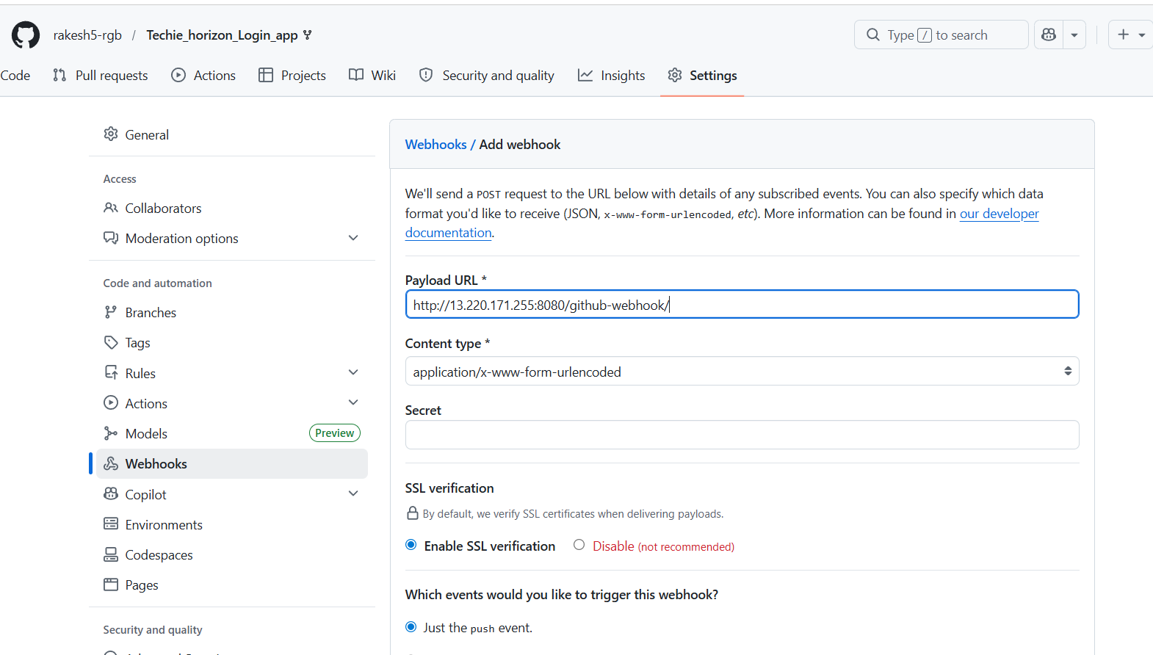
Select on what event the build should trigger --- click on add webhook
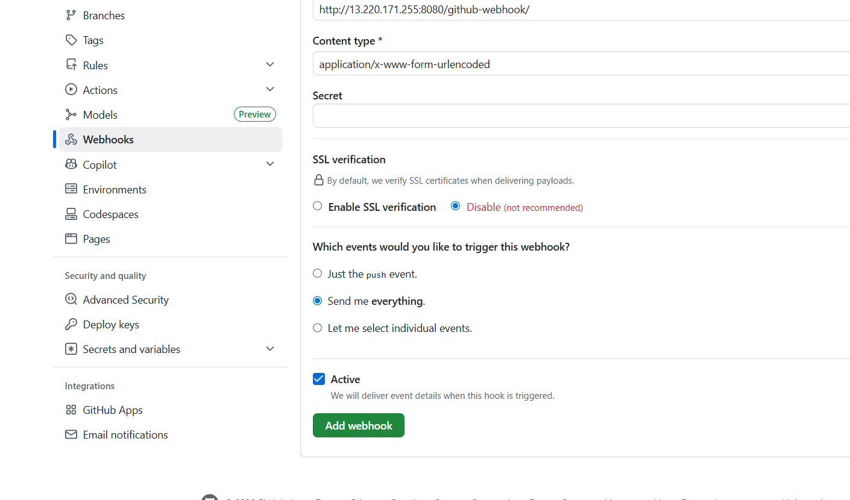
Setup is successfully done

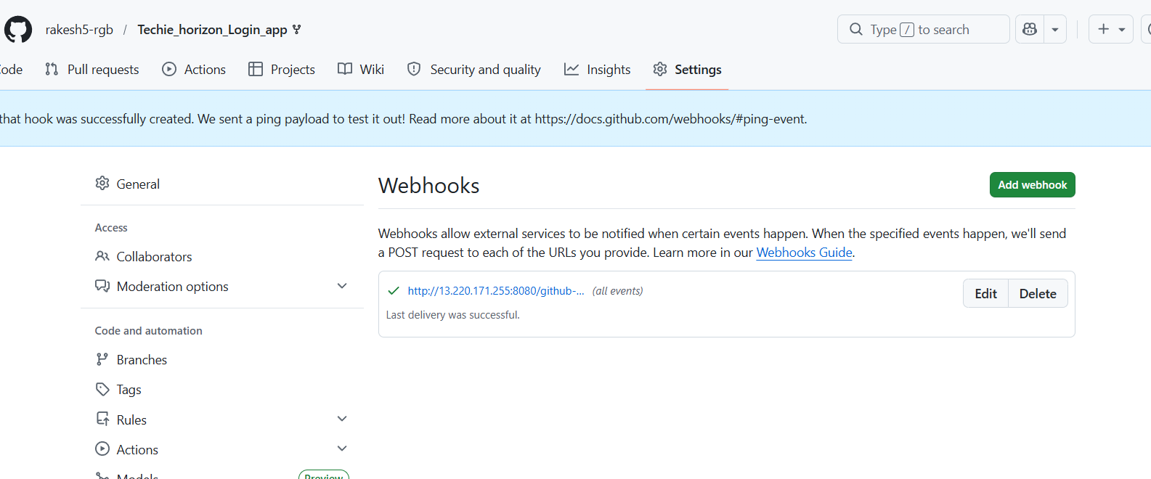
I tried making changes in repo
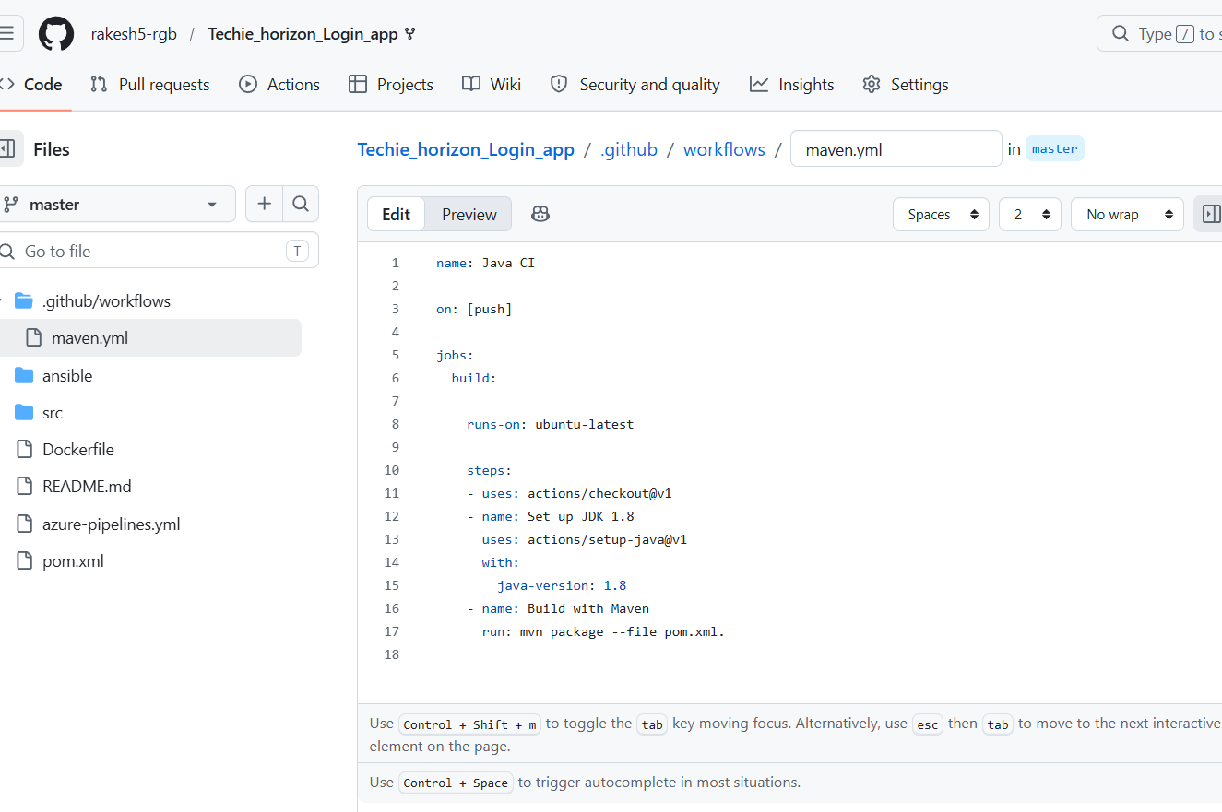

We can able to see that the job is built
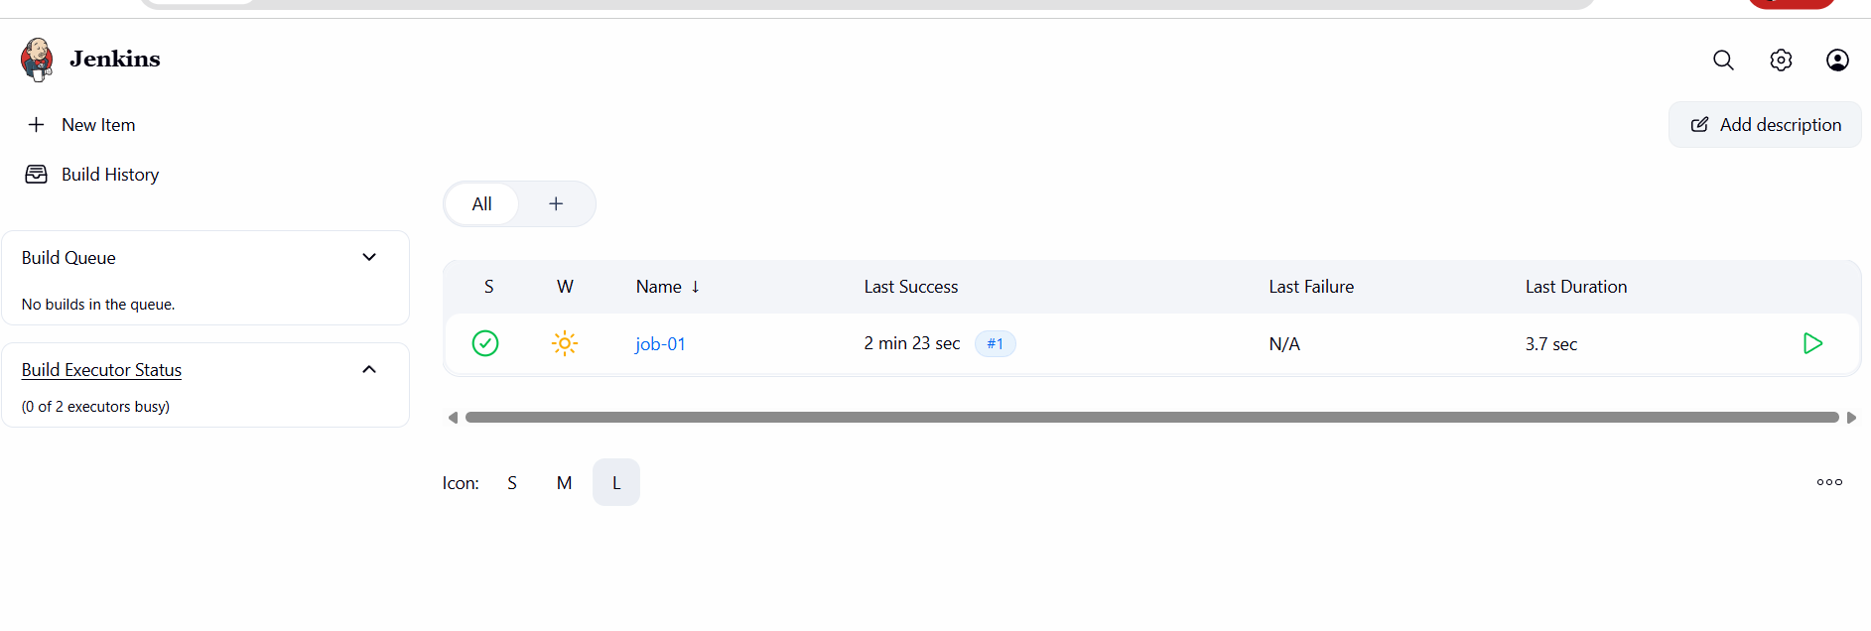

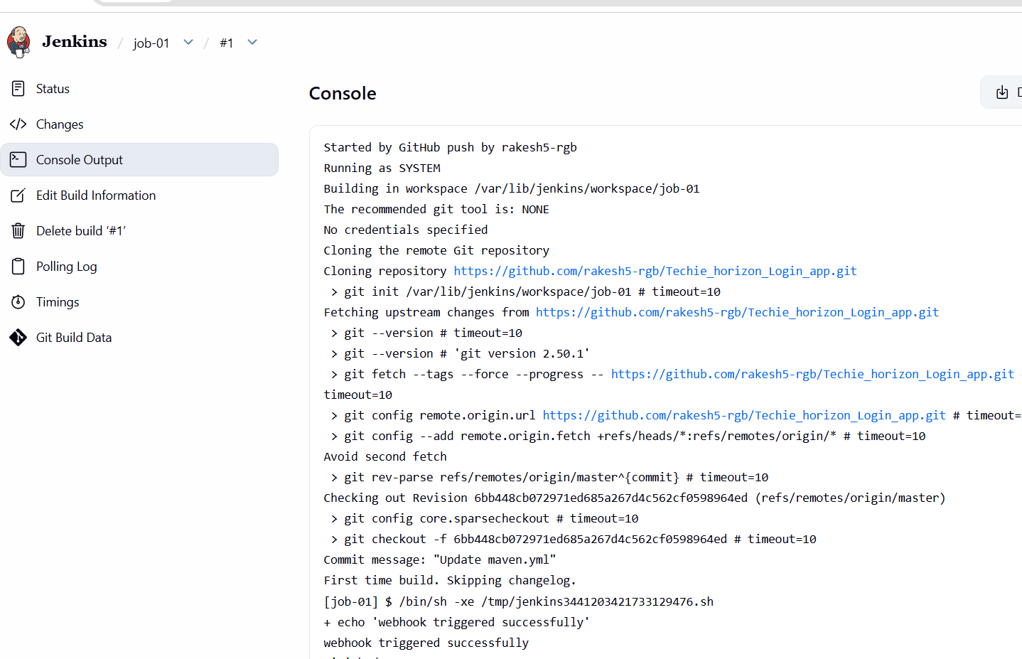

- ConfigurePoll SCMandBuild Periodicallyoptions in the Jenkins job.
Go to the Jenkins and create a new item
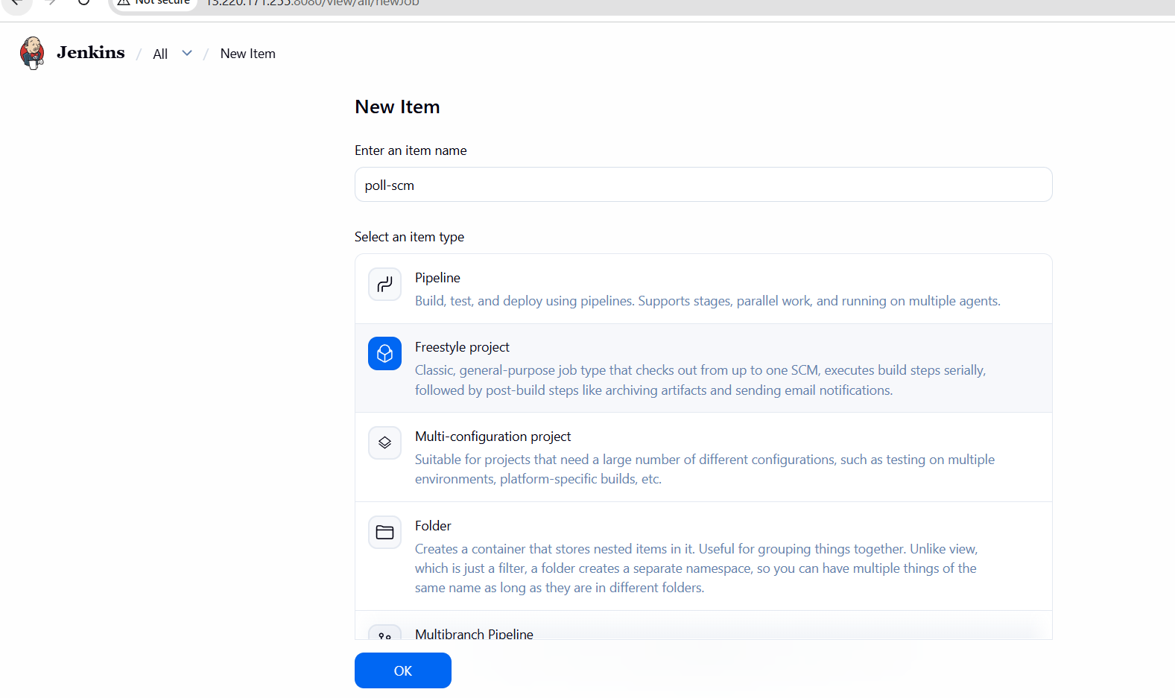
Select git repo
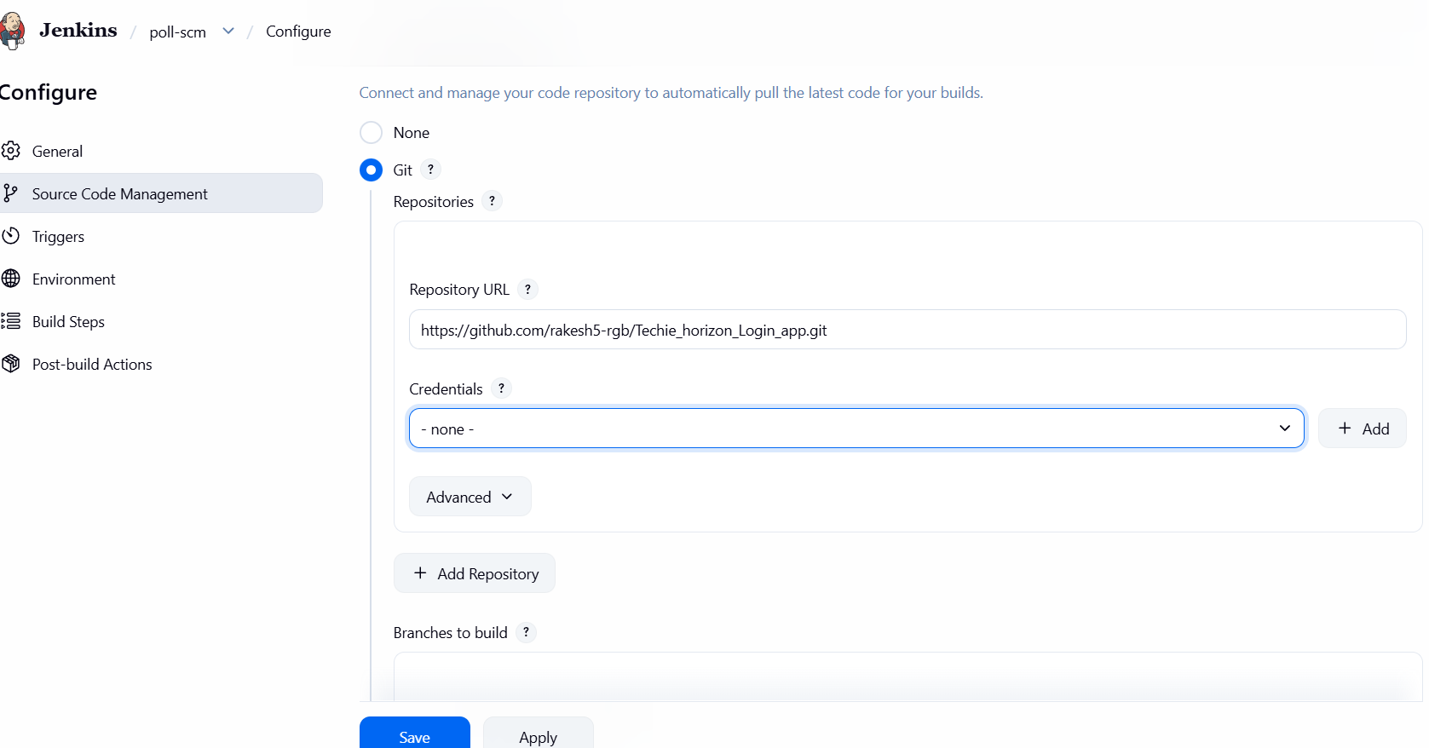
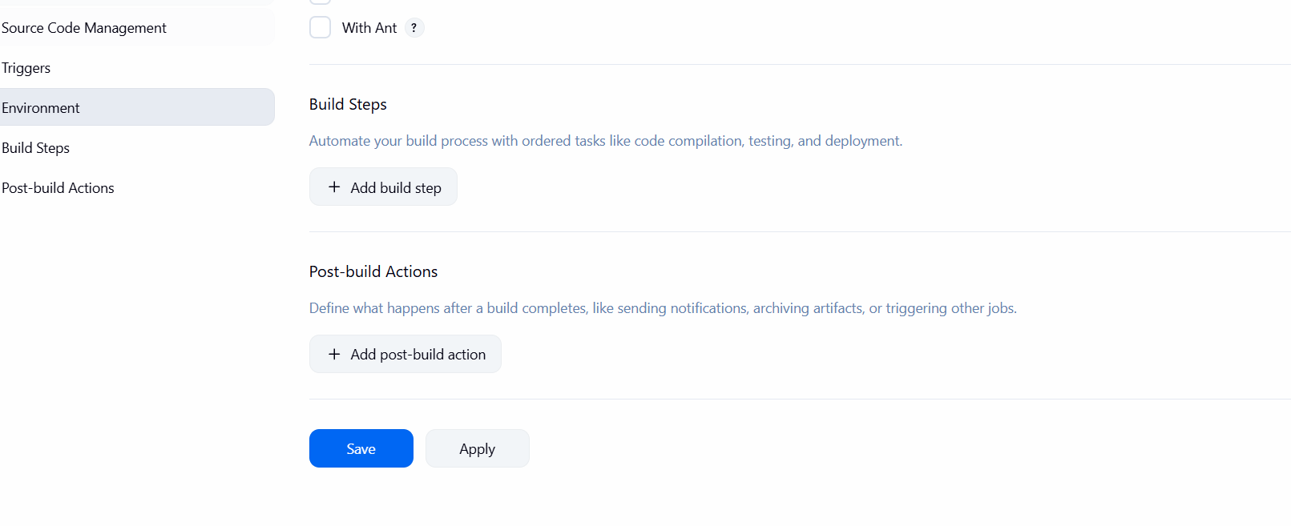
Select pollSCM under triggers
Here we are scheduling for every min, every hour, every day. So that whenever we make any
changes in repo then the job will run
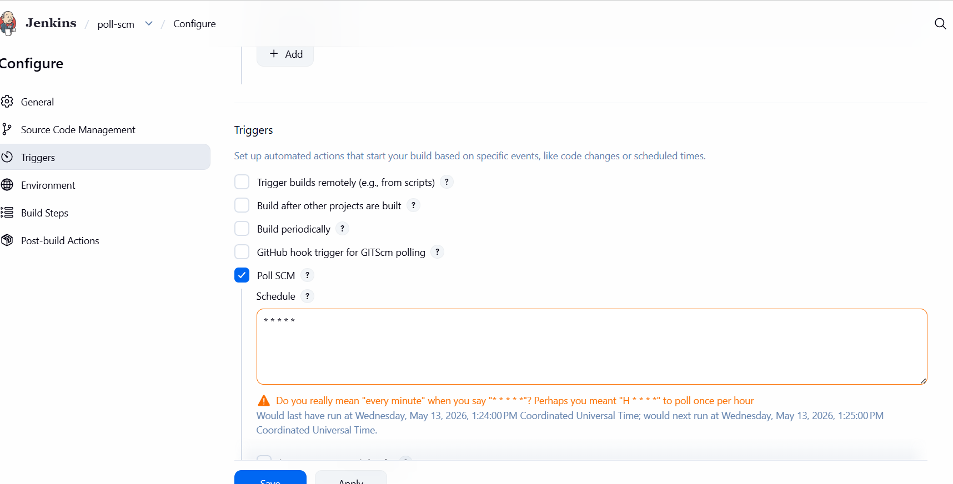

Now I am making changes in repo like deleted a dot(.)

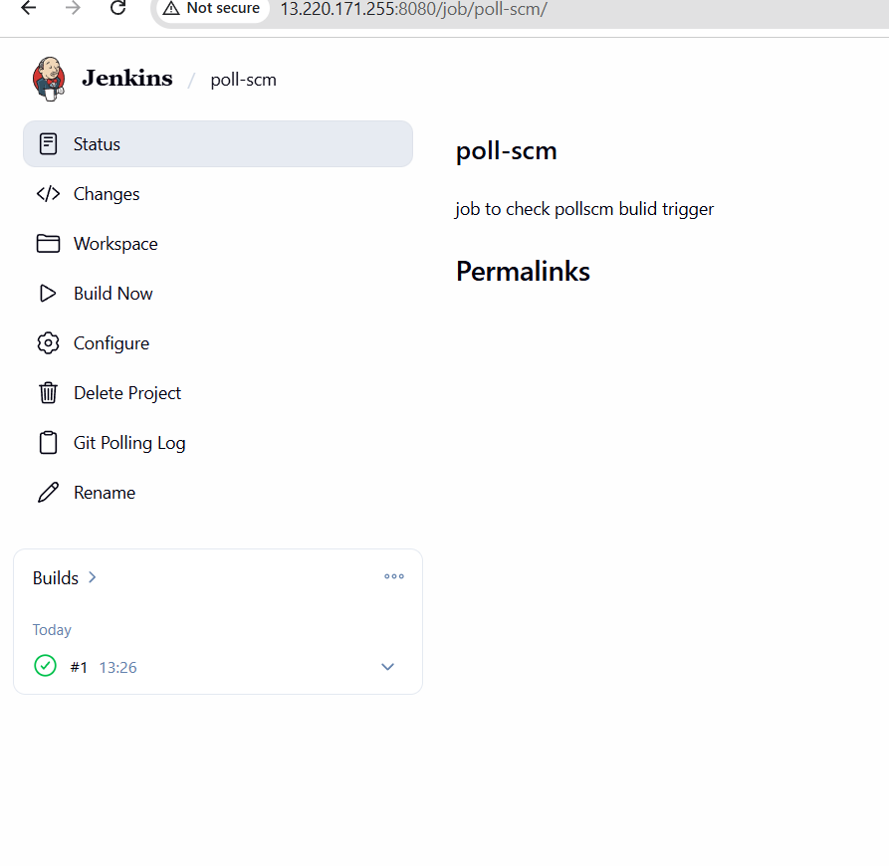
Here the build is triggered
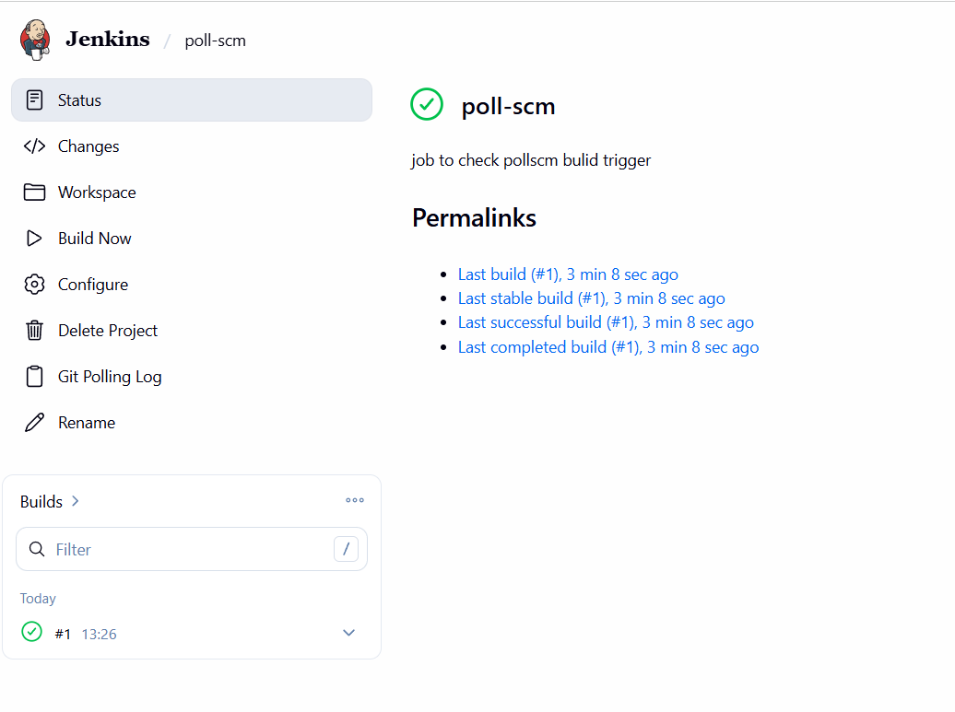
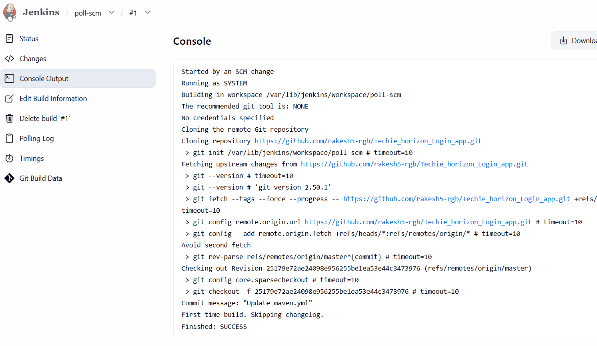
Lets try build periodically
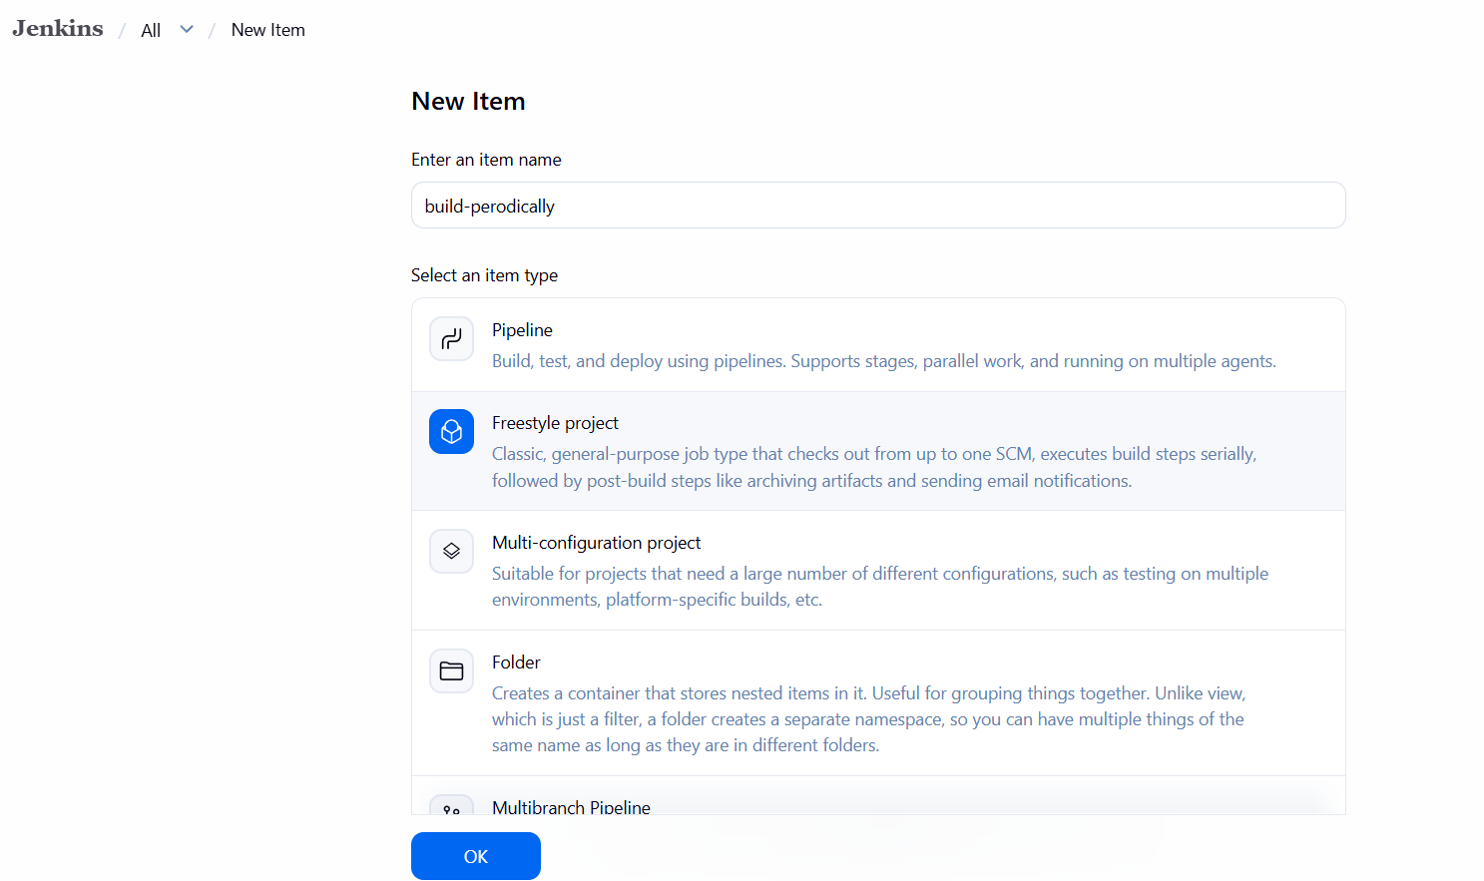
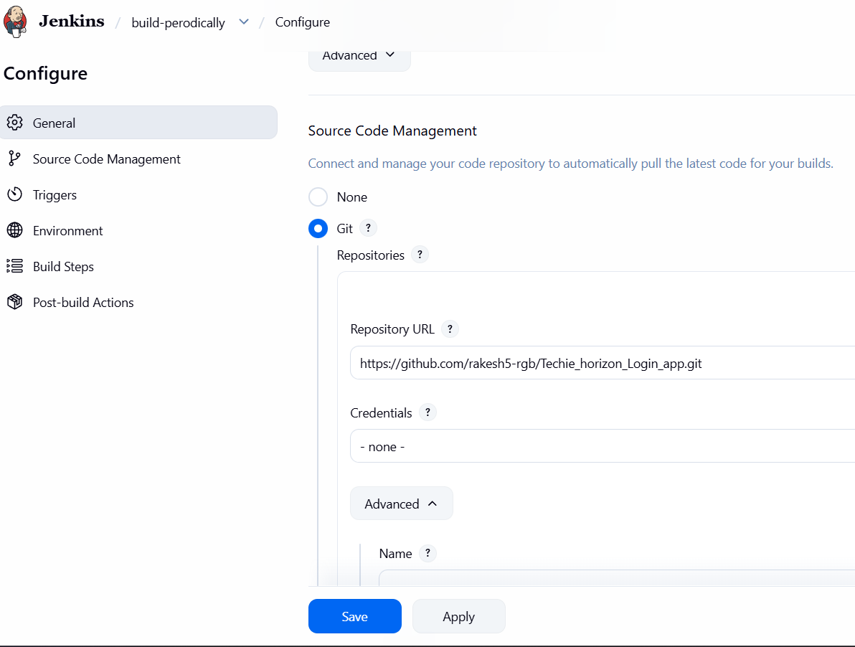
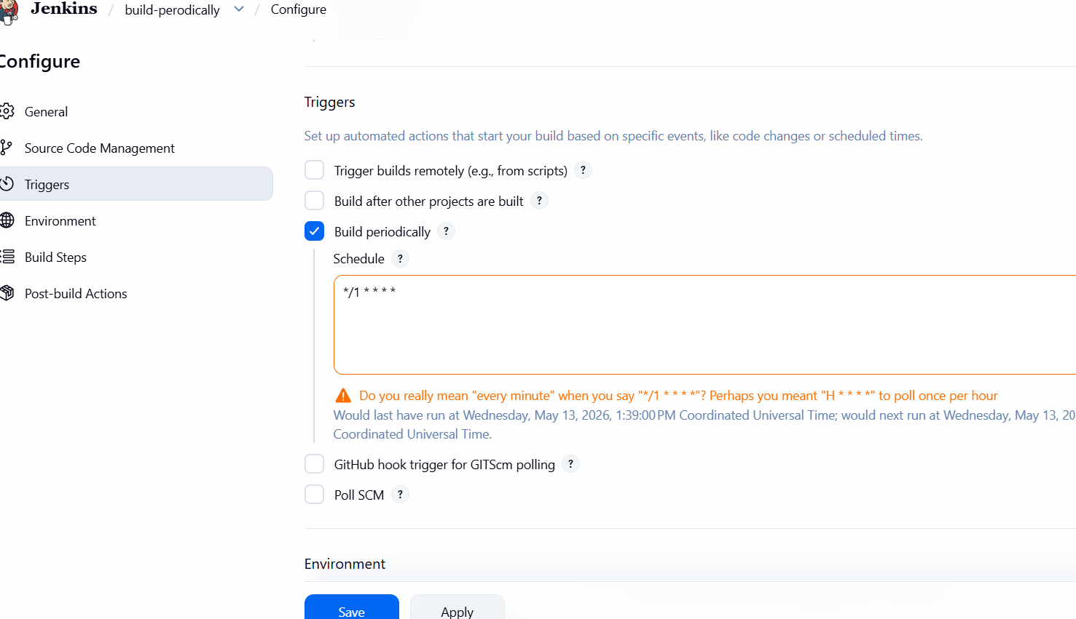

For every 1 minute the build is triggering
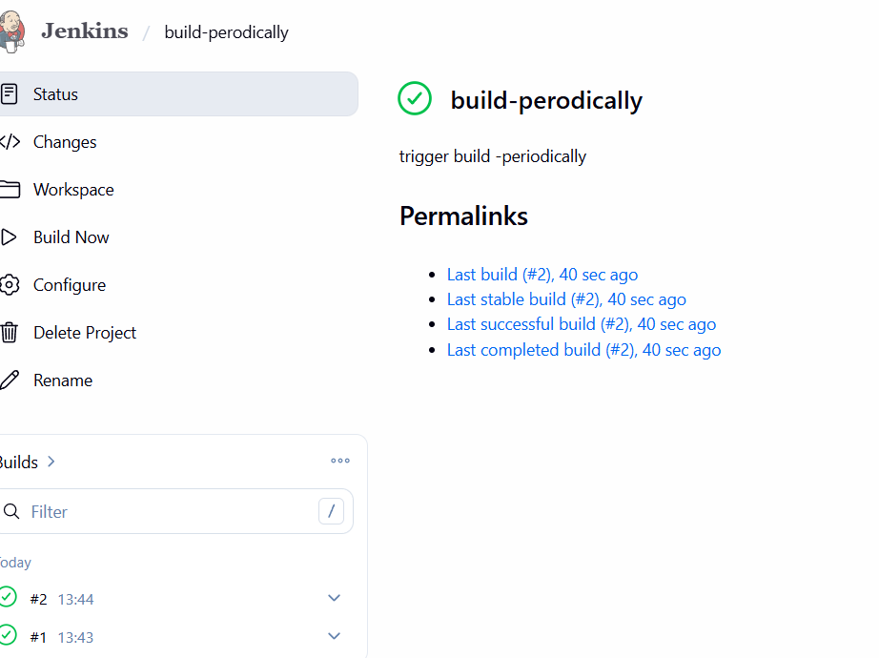
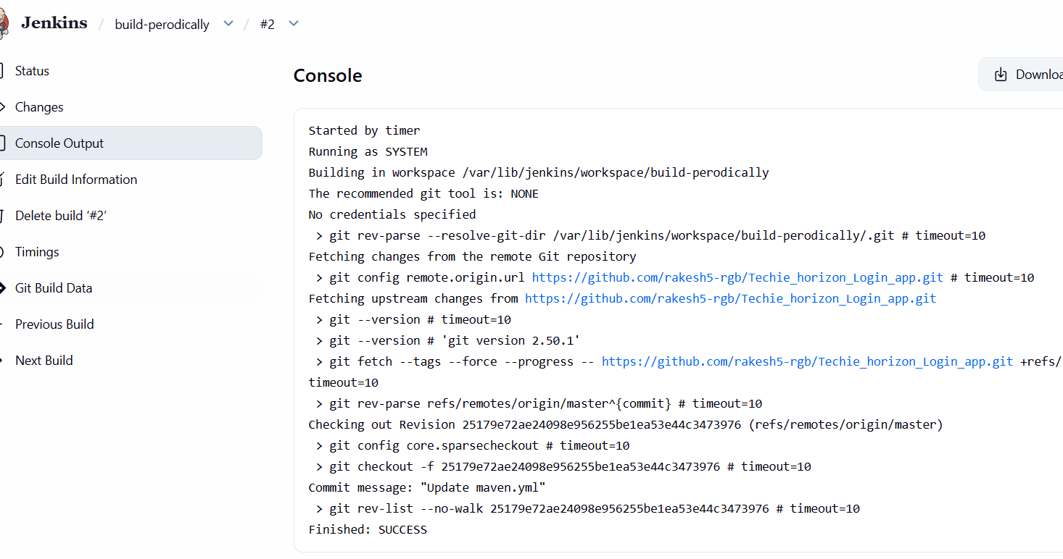

Build Periodically triggers builds based on time schedule, whereas Poll SCM checks source code repository for changes and triggers build only when changes are detected.
- Take a backup of the Jenkins server using a bash-script.

Bash script to take backup of our server
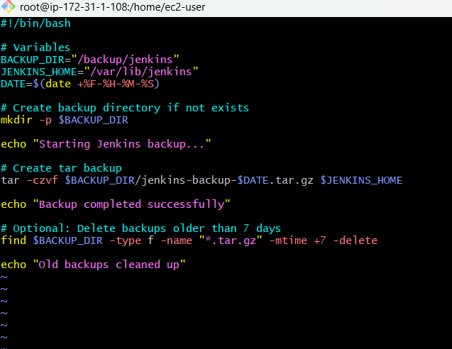

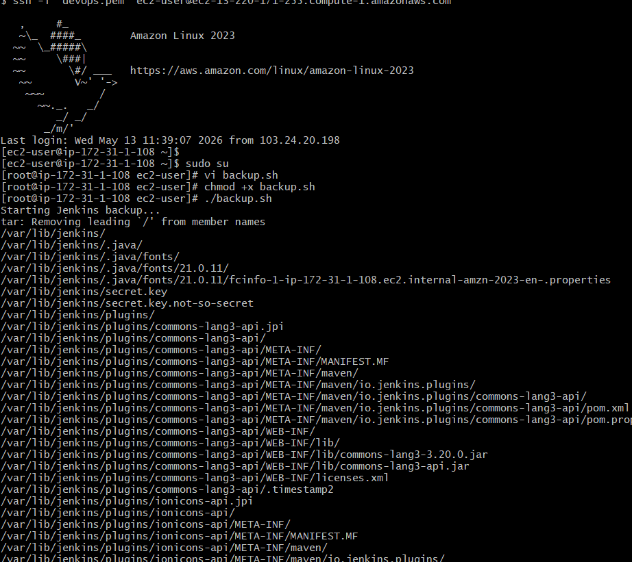
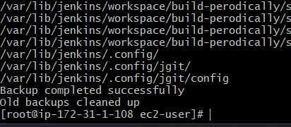
files in workspace folder
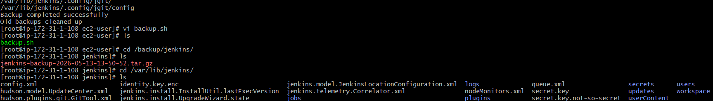

- Take a backup of Jenkins using theThinBackupplugin.
Go to manage ---- plugins
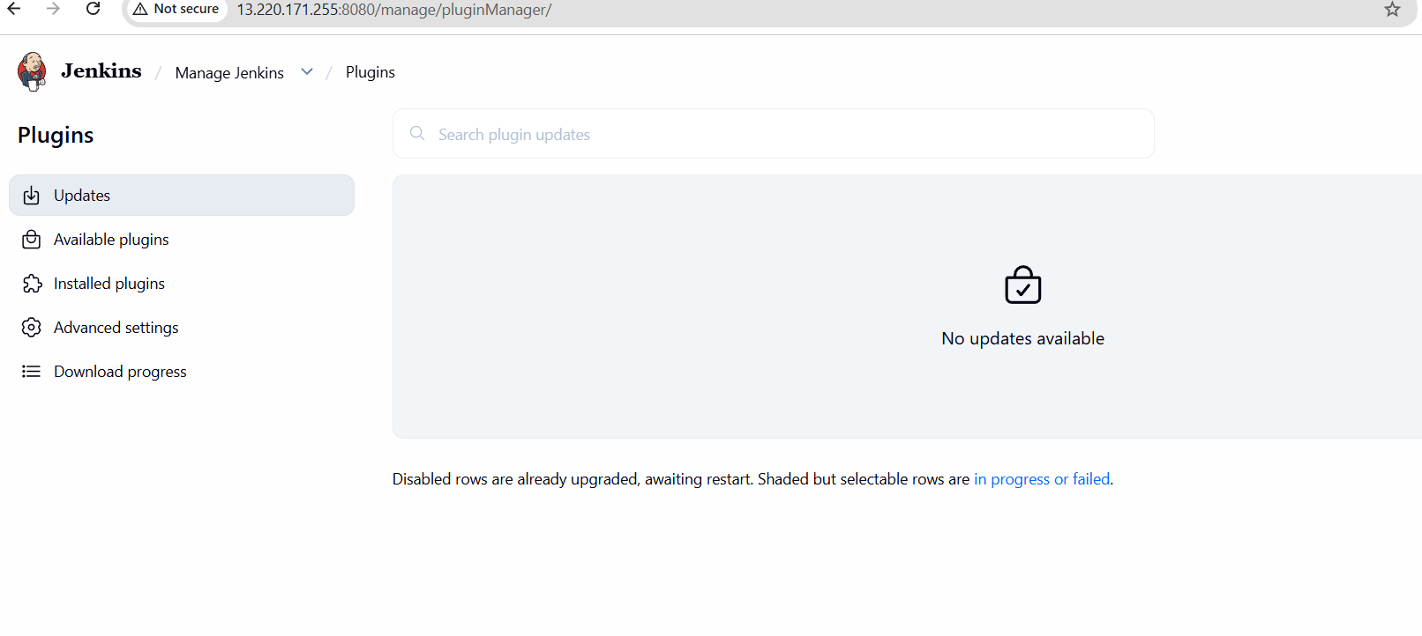
Install the plugin
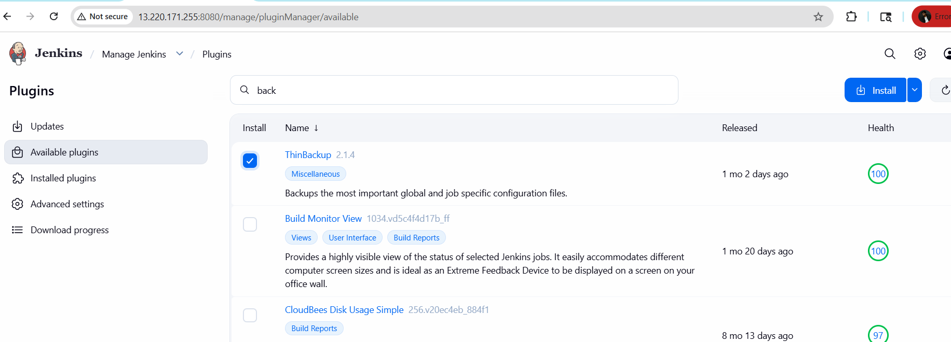
Installed successfully
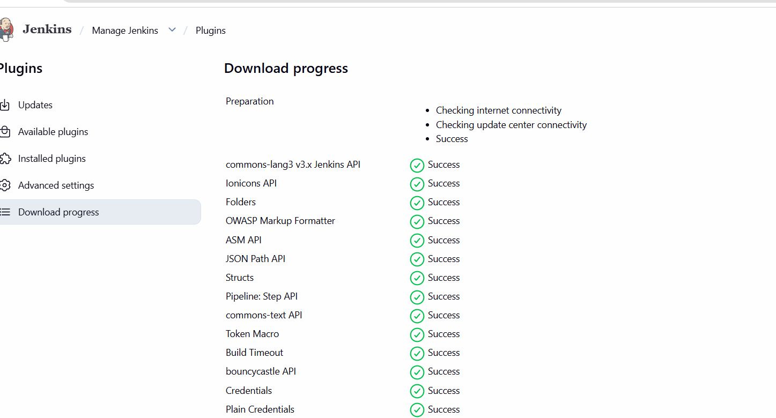
go to manage Jenkins --- Click on system
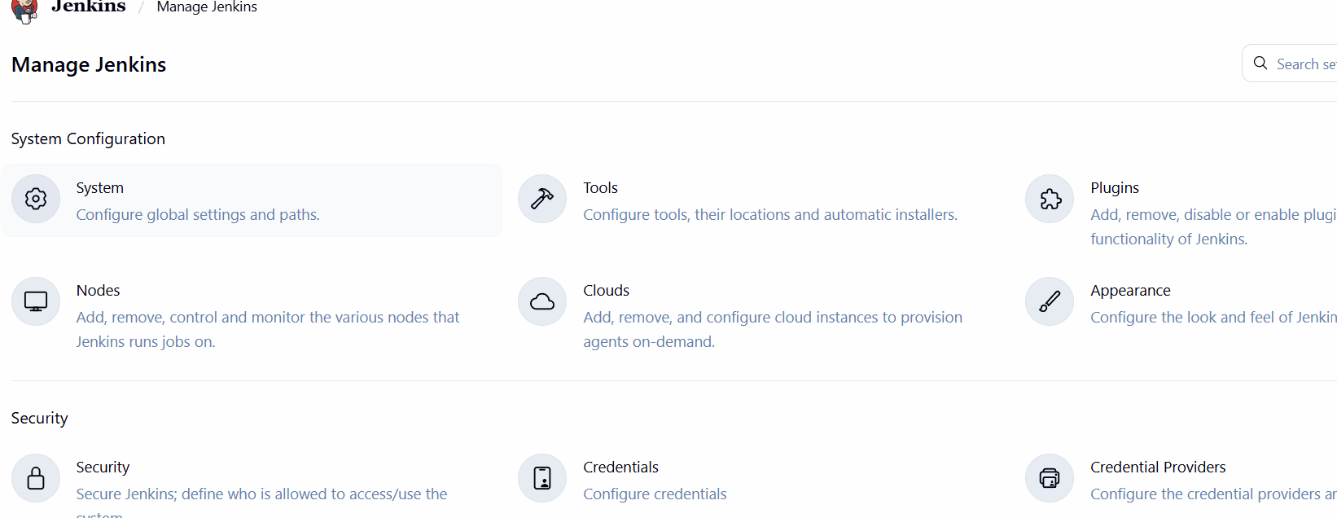
Click on system --- choose thinbackup configuration
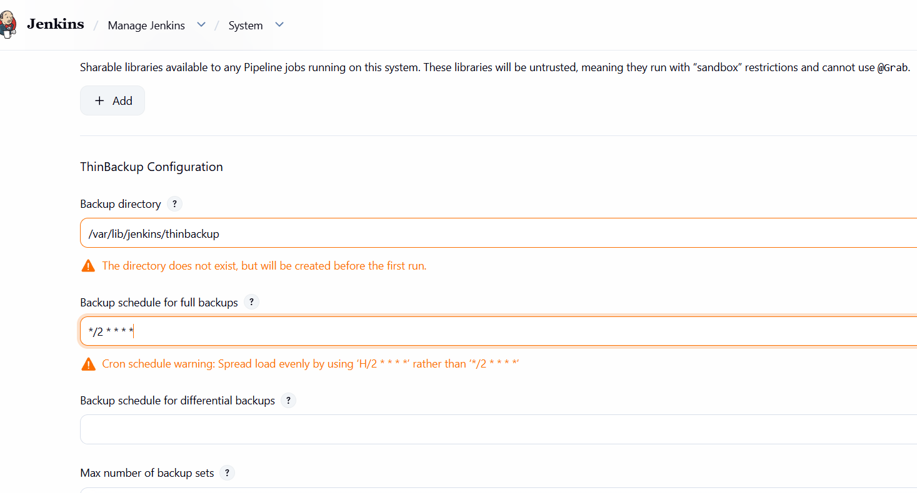
Creating backup directory and scheduling it for every 2 mins means the backup will
Be taken every 2 mins
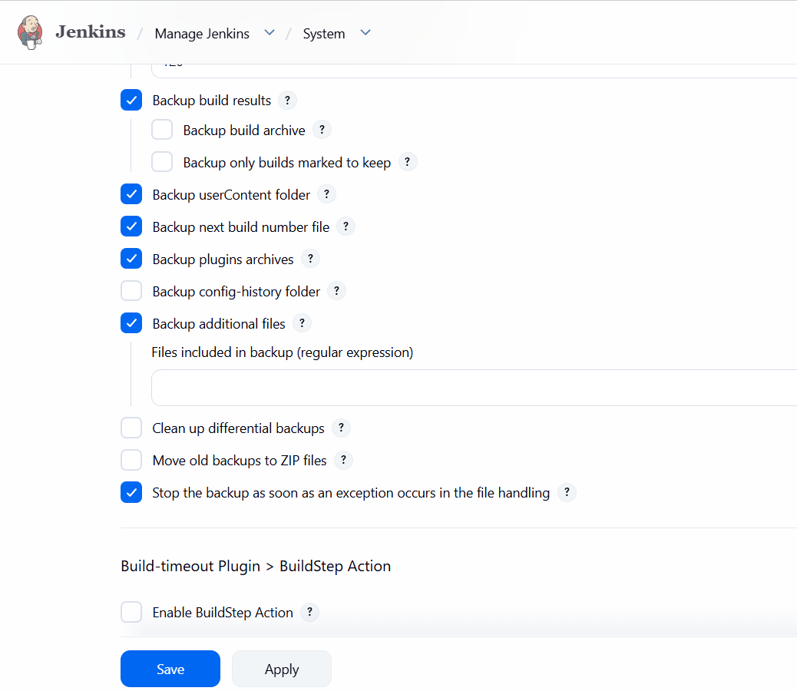
The backup is now setup and we will create backup manually
Go to manage Jenkins -- tools and actions --- Thinbackup ---- click on backup
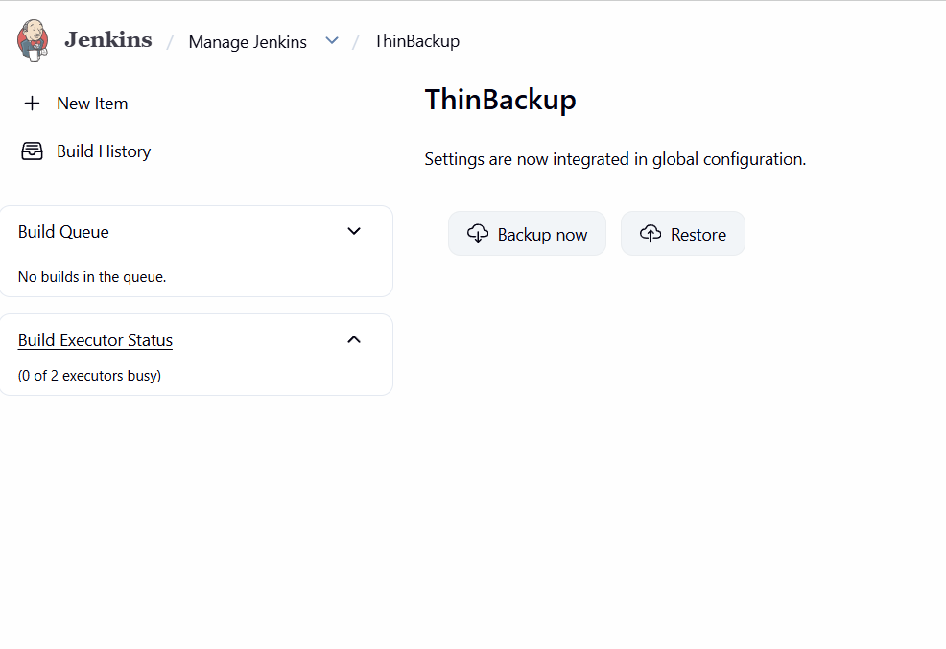
Verify in Jenkins server
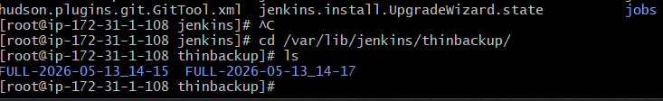
- Set up a new Jenkins server and restore the backup taken in task 4.

Create a new instance instance
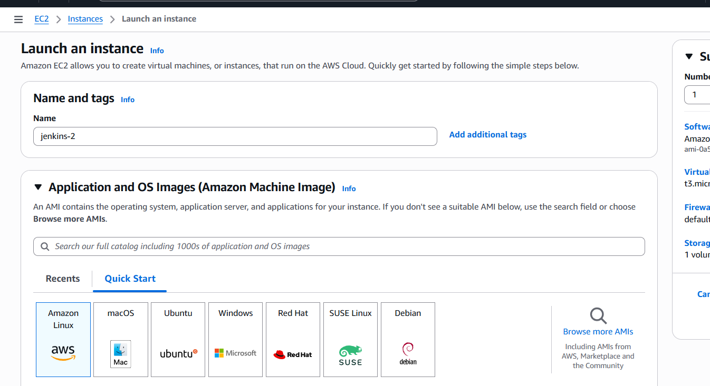
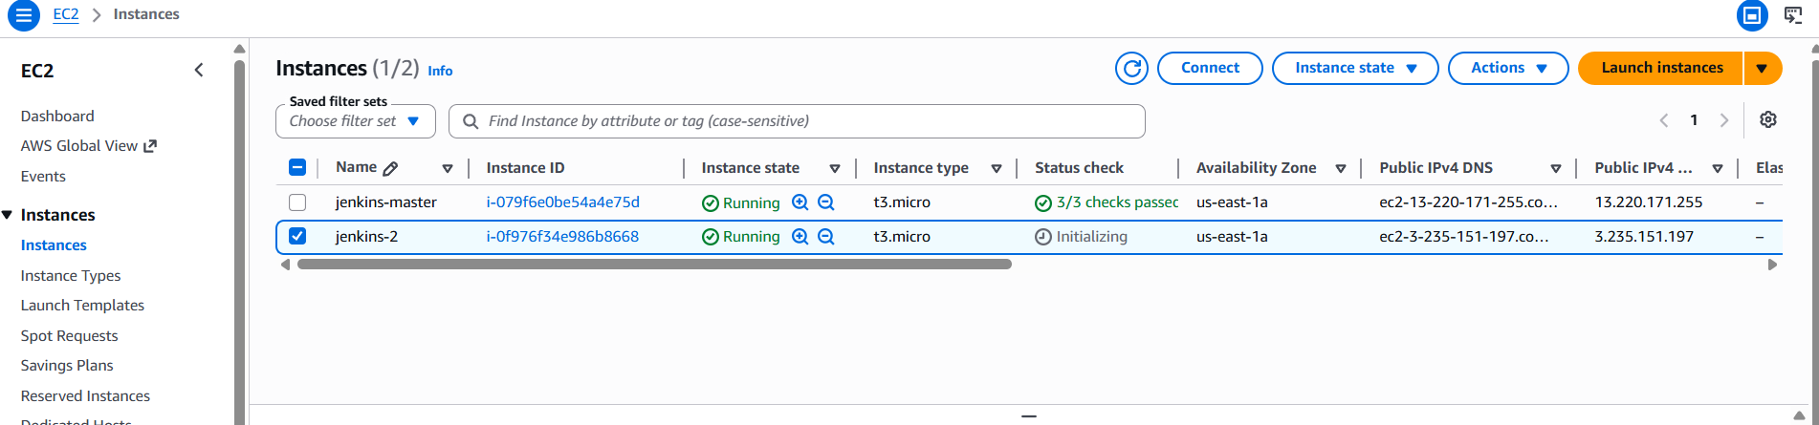

We need to copy the pem key of our new instance on our old instance
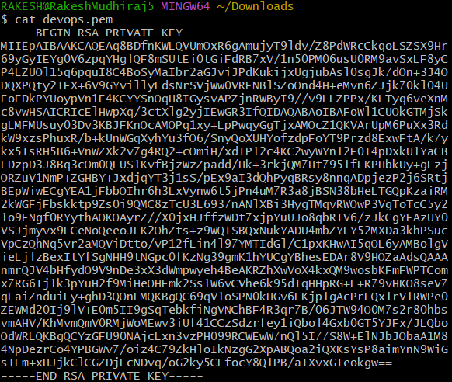
From our old instance we need to do secure copy our tar file to new instance using command
scp -i test.pem /backup/jenkins/jenkins-backup-2026-05-13-10-01-50.tar.gz ec2-user@44.212.11.171:/tmp
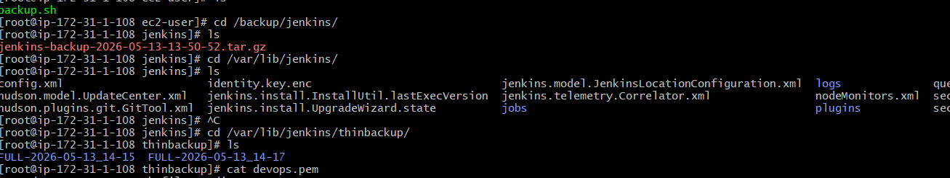
Here we can see back up of file in other instance
